**VISVESVARAYA TECHNOLOGICAL UNIVERSITY**

**“JnanaSangama”, Belgaum -590014, Karnataka.**



**LAB REPORT**

**on**

**Object Oriented Modelling Design**

***Submitted by***

**VAIBHAVI PATIL (1BM19CS217)**

***in partial fulfillment for the award of the degree of***

**BACHELOR OF ENGINEERING**

***in***

**COMPUTER SCIENCE AND ENGINEERING**



**B.M.S. COLLEGE OF ENGINEERING**

**(Autonomous Institution under VTU)**

**BENGALURU-560019**

**April-2022 to July-2022**

**B. M. S. College of Engineering,**

**Bull Temple Road, Bangalore 560019**

(Affiliated To Visvesvaraya Technological University, Belgaum)

**Department of Computer Science and Engineering**



**CERTIFICATE**

This is to certify that the Lab work entitled “**Object Oriented Modelling Design**” carried out by **VAIBHAVI PATIL (1BM19CS217),** who is bonafide student of **B. M. S. College of Engineering.** It is in partial fulfillment for the award of **Bachelor of Engineering in Computer Science and Engineering** of the Visvesvaraya Technological University, Belgaum during the academic year 2021-2022.The Lab report has been approved as it satisfies the academic requirements in respect of **Object Oriented Modelling Design** **- (20CS6PCOOMD)** work prescribed for the said degree.

Sheetal VA            **Dr. Jyothi S Nayak**

Assistant professor Professor and Head

Department of CSE Department of CSE

BMSCE, Bengaluru BMSCE, Bengaluru

`

**Index Sheet**

|  |  |  |
| --- | --- | --- |
| **Sl. No.** | **Experiment Title** | **Page No.** |
| **1** | **College information system** | **04** |
| **2** | **Hostel management system** | **14** |
| **3** | **Stock management system** | **23** |
| **4** | **Coffee vending machine** | **33** |
| **5** | **Online shopping system** | **43** |
| **6** | **Railway reservation system** | **53** |
| **7** | **Graphics editor system** | **63** |
|  |  |  |
|  |  |  |
|  |  |  |
|  |  |  |
|  |  |  |
|  |  |  |
|  |  |  |
|  |  |  |

**Course Outcome**

|  |  |
| --- | --- |
| **CO4** | **Ability to conduct practical experiment to solve a given problem using Unified Modeling language.** |

**LAB1: ONLINE SHOPPING SYSTEM**

**SRS**

**Problem Statement**

An online shopping mobile/web application where the vendors can advertise their products on the portal and users can choose their product they want to buy. The system offers various payment methods.

**System Requirement Specification**

**Functional Requirements:**

Customers can browse through products by category.

Portal includes a recommendation system to suit customers.

Vendors can add their products with description and their price.

Vendors can view orders and the date of product pickup by the delivery agency.

The customers can add items to cart or save them for later purchase.

Portal will include a mechanism to track delivery of the products.

Customers can choose their desired mode of shipping and location.

**Non-Functional Requirement:**

The system should be developed within the budget specified.

The database should be secure.

ADVANCED CLASS DIAGRAM

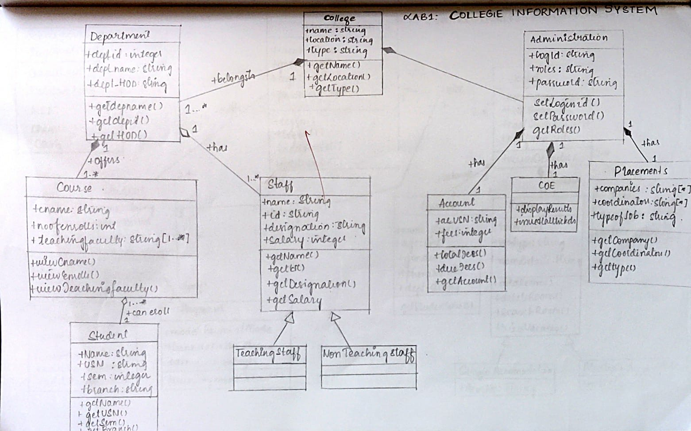

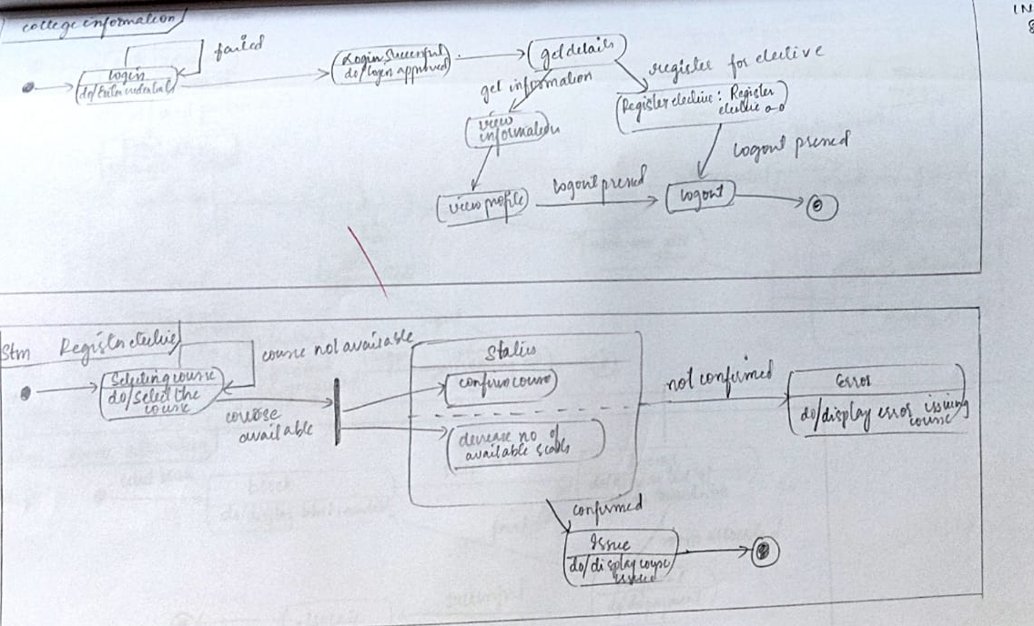 ADVANCED STATE DIAGRAM

ADVANCED USE CASE DIAGRAM

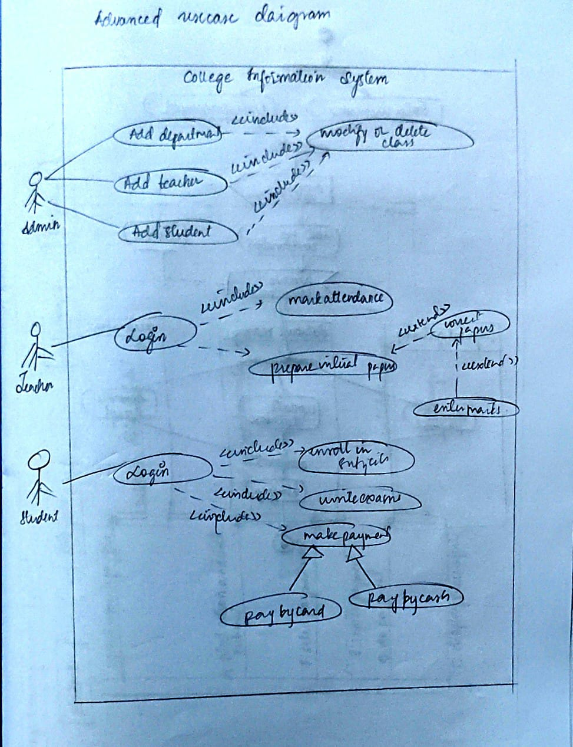

ADVANCED ACTIVITY DIAGRAM

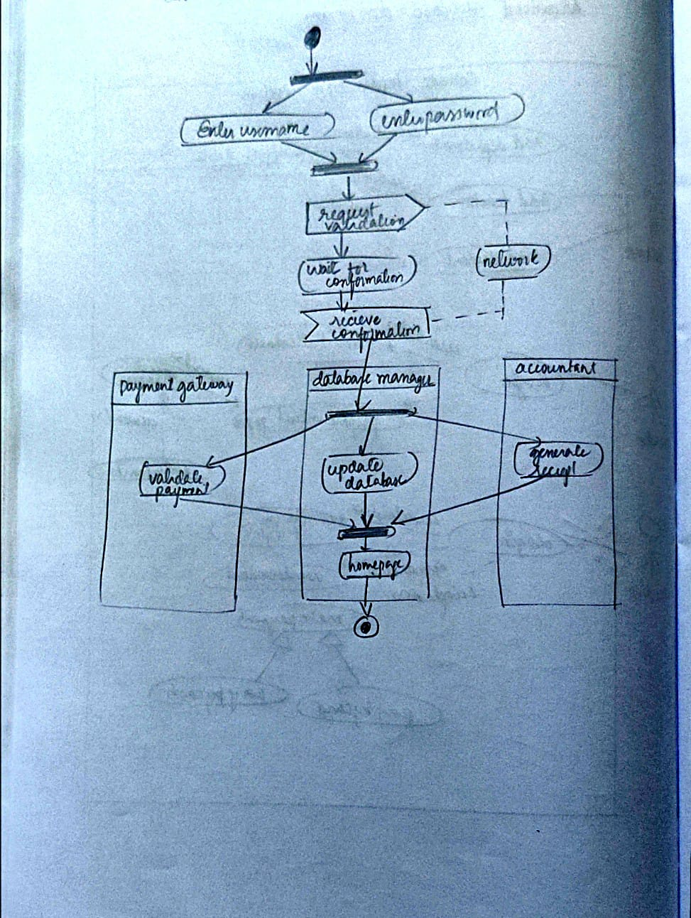

ADVANCED SEQUENCE DIAGRAM

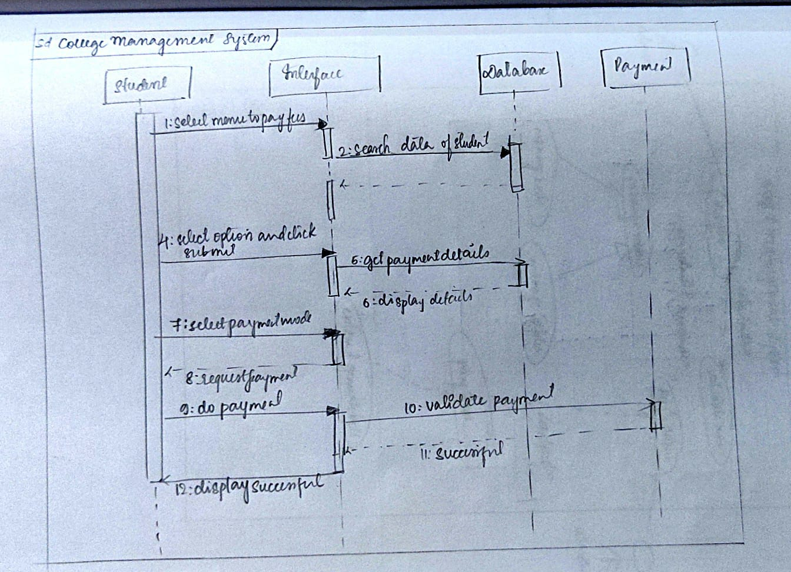

ADVANCED CLASS DIAGRAM

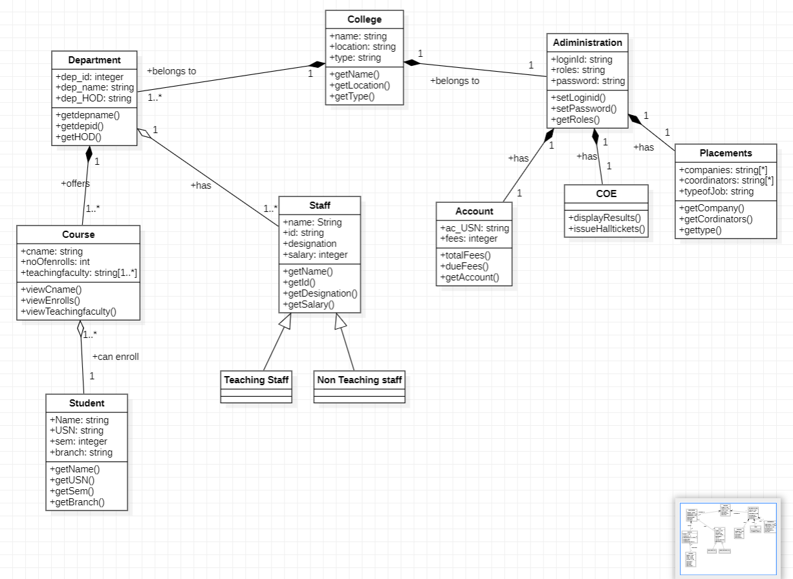

ADVANCED STATE DIAGRAM

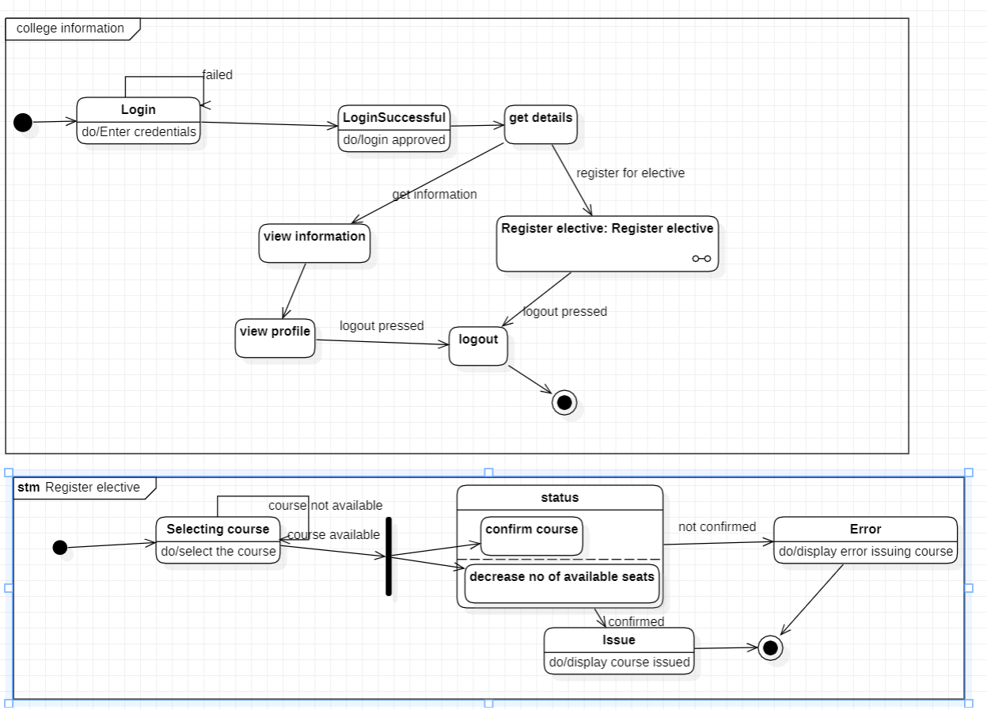

ADVANCED USE CASE DIAGRAM

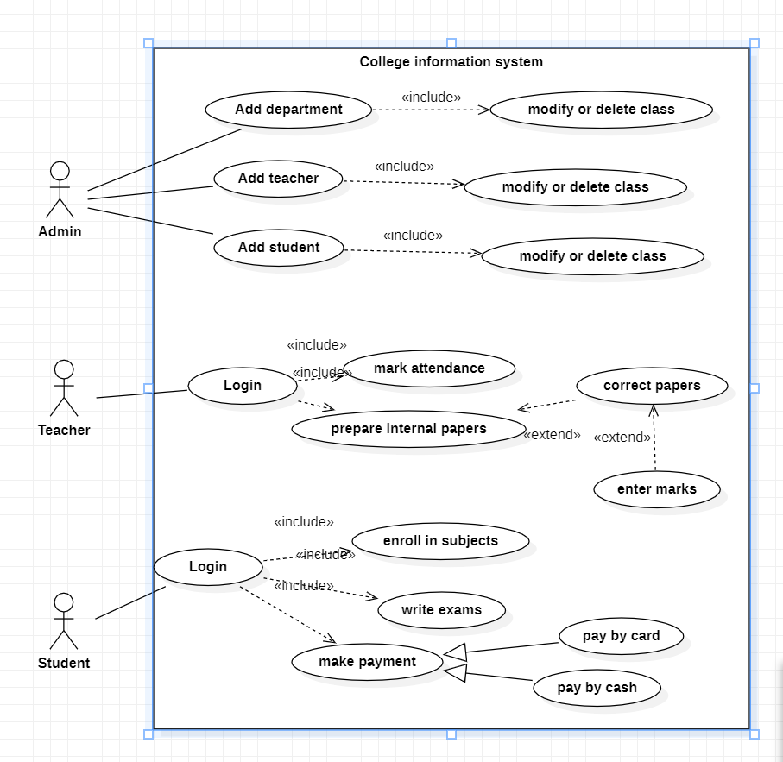

ADVANCED ACTIVITY DIAGRAM

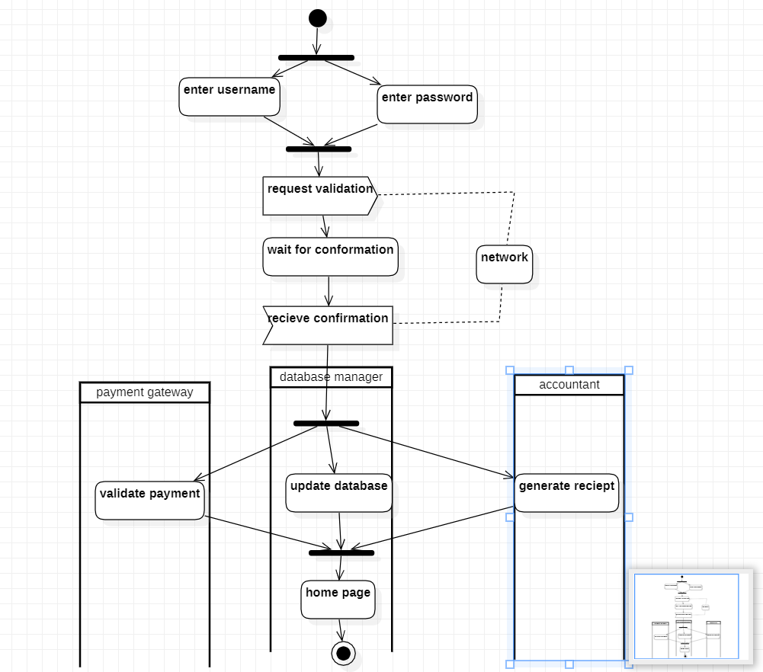

ADVANCED SEQUENCE DIAGRAM

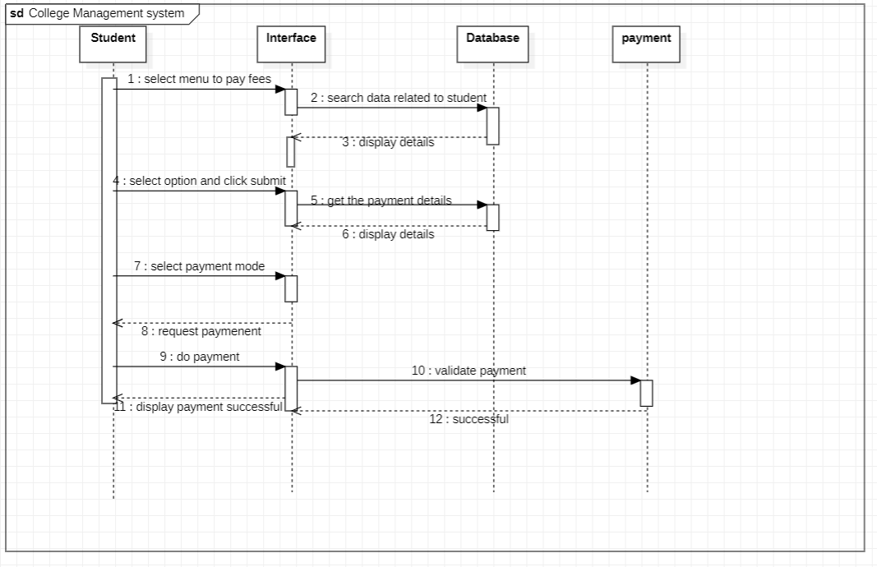

**LAB2: HOSTEL MANAGEMENT**

**SRS**

**Problem Statement**

To enable a fullfleged hostel management system that will digitalise the information of the student and hostel management staff to enable convenient storage, retrieval and management of information.

**Software Requirement Specification**

**Functional Requirements:**

The admin can login and allot room to students.

The students can pay the hostel fees.

Students can view the mess menu and provide feedback.

Students can select the mess manager.

Mess manager can update the mess menu.

Mess managers can review the mess feedback.

Admin can view the feedback provided by the students.

**Non-Functional Requirements:**

The database storing the details must be secure.

The database should be able to store the log records in an understandable manner.

Easy insertion, updation and retrieval of information.

ADVANCED CLASS DIAGRAM

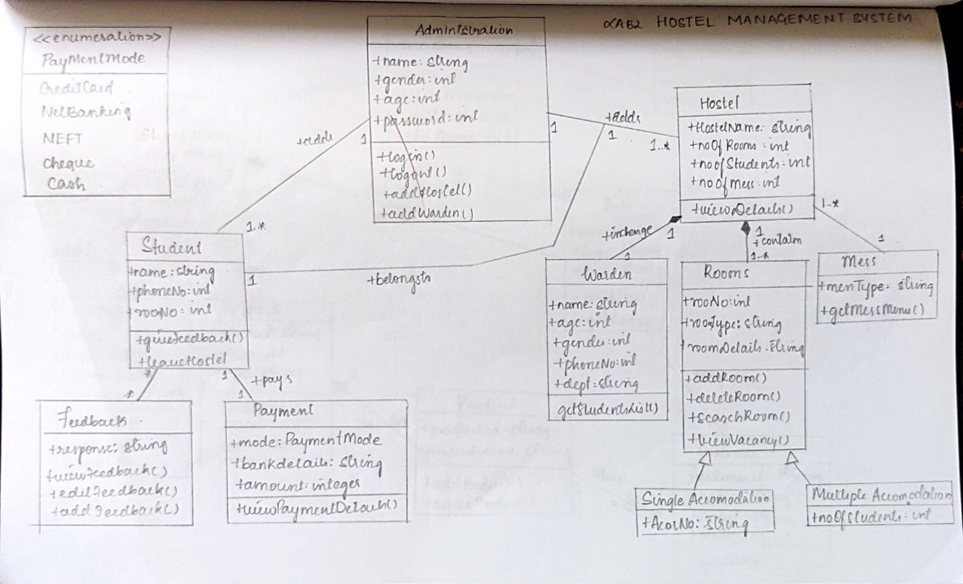

ADVANCED STATE DIAGRAM

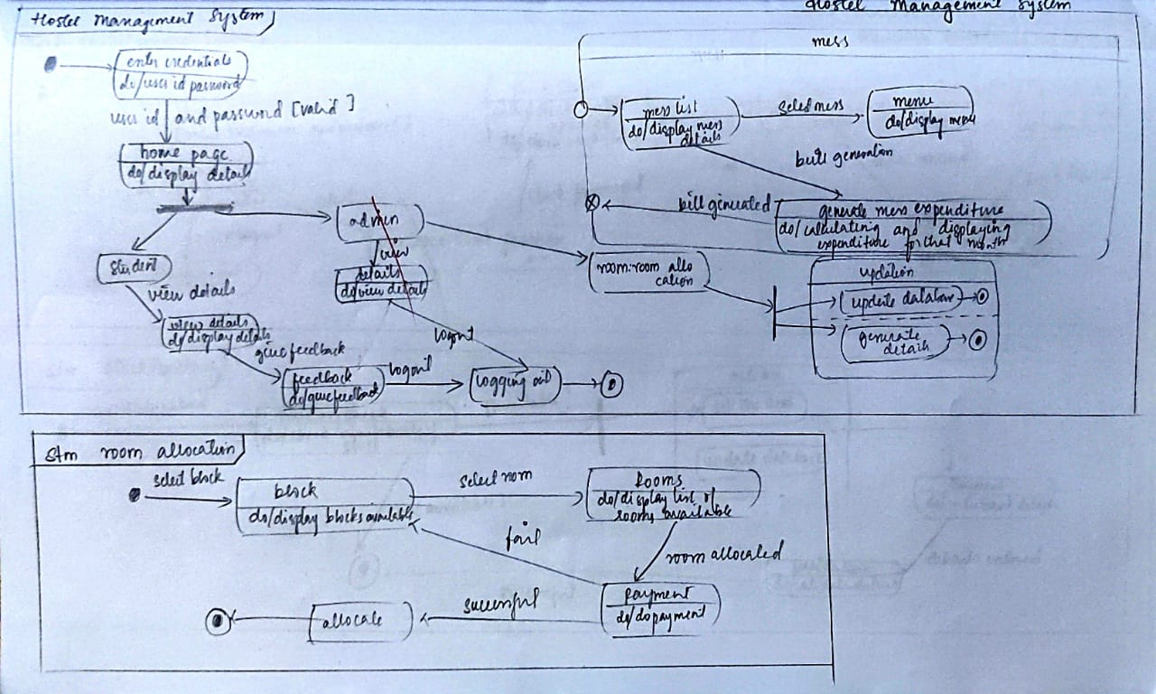

ADVANCED USE CASE DIAGRAM

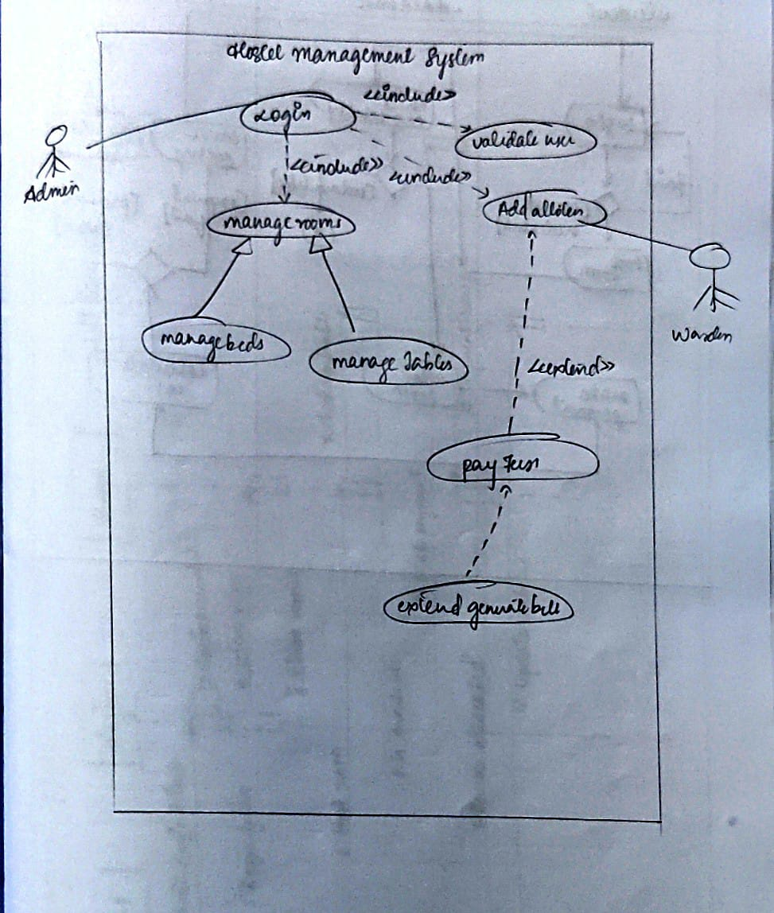

ADVANCED ACTIVITY DIAGRAM

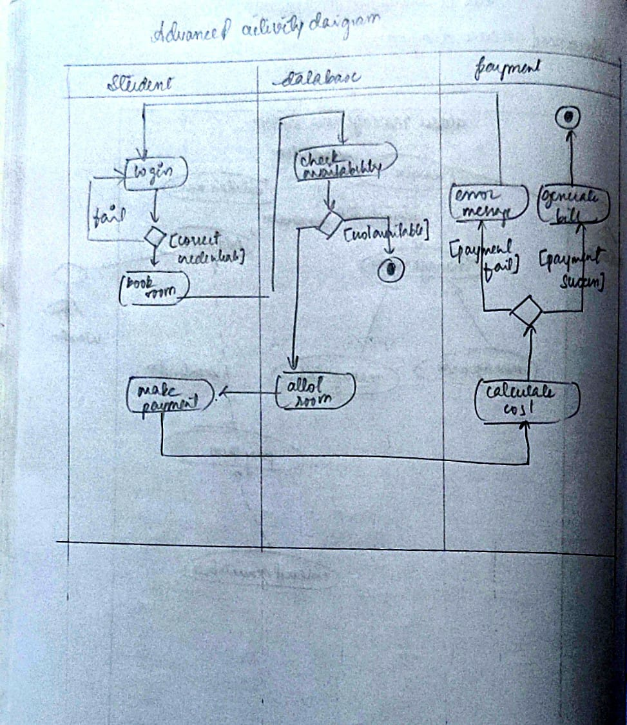

ADVANCED SEQUENCE DIAGRAM

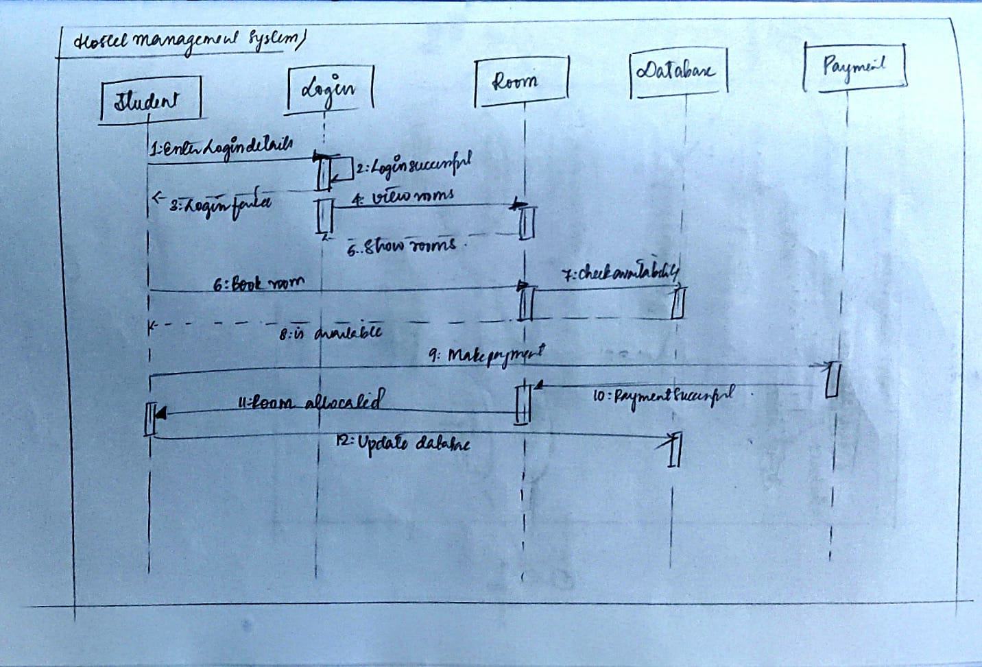

ADVANCED CLASS DIAGRAM

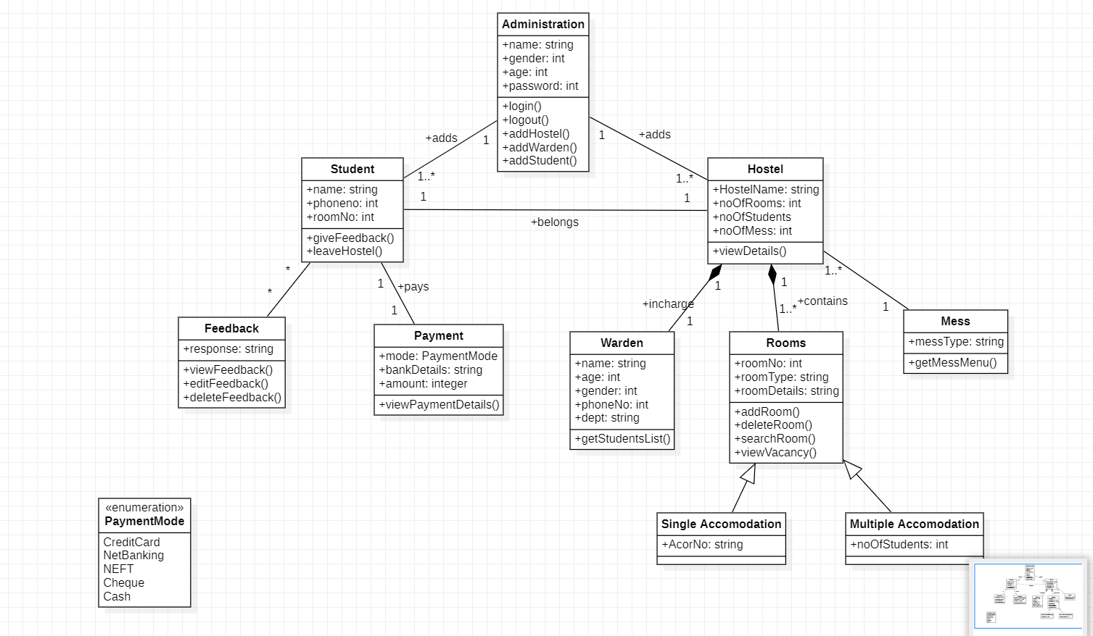

ADVANCED STATE DIAGRAM

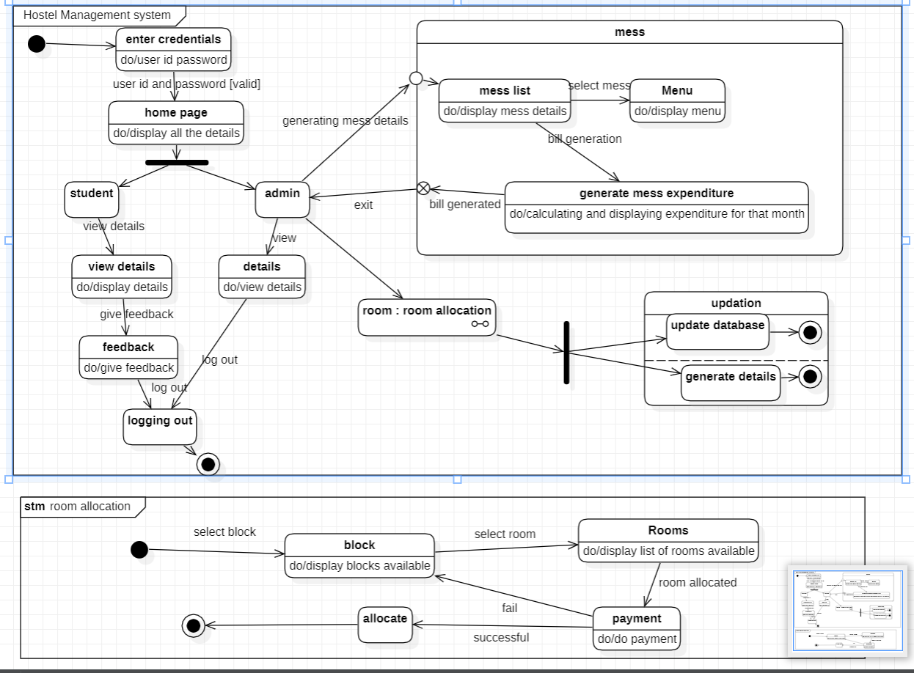

ADVANCED USE CASE DIAGRAM

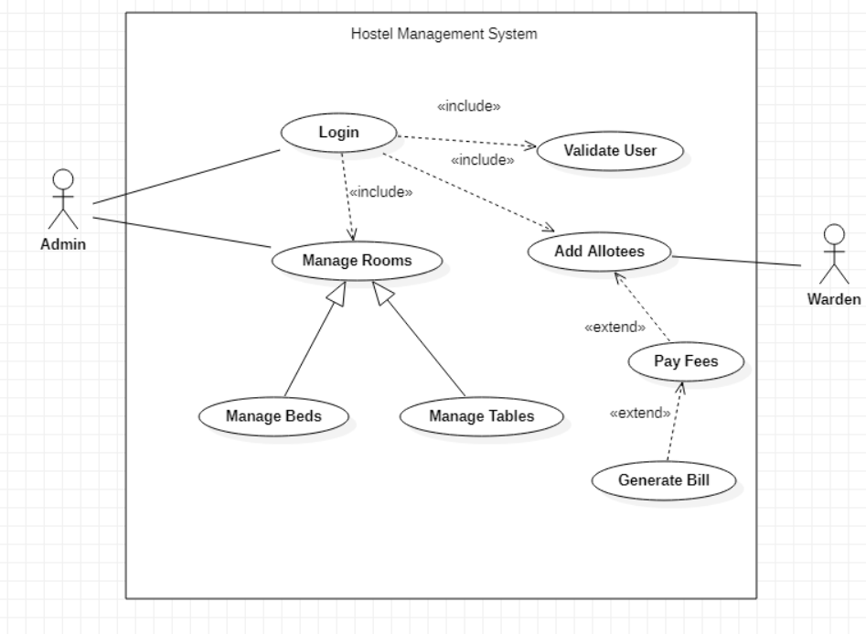

ADVANCED ACTIVITY DIAGRAM

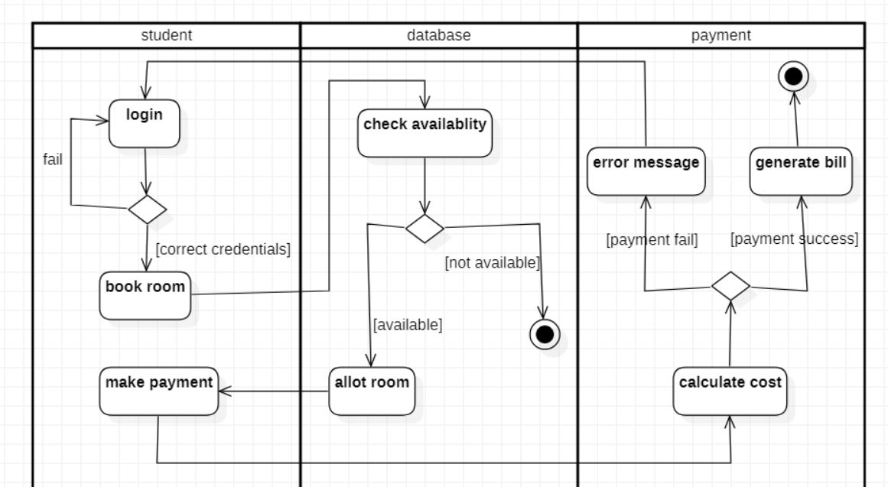

ADVANCED SEQUENCE DIAGRAM

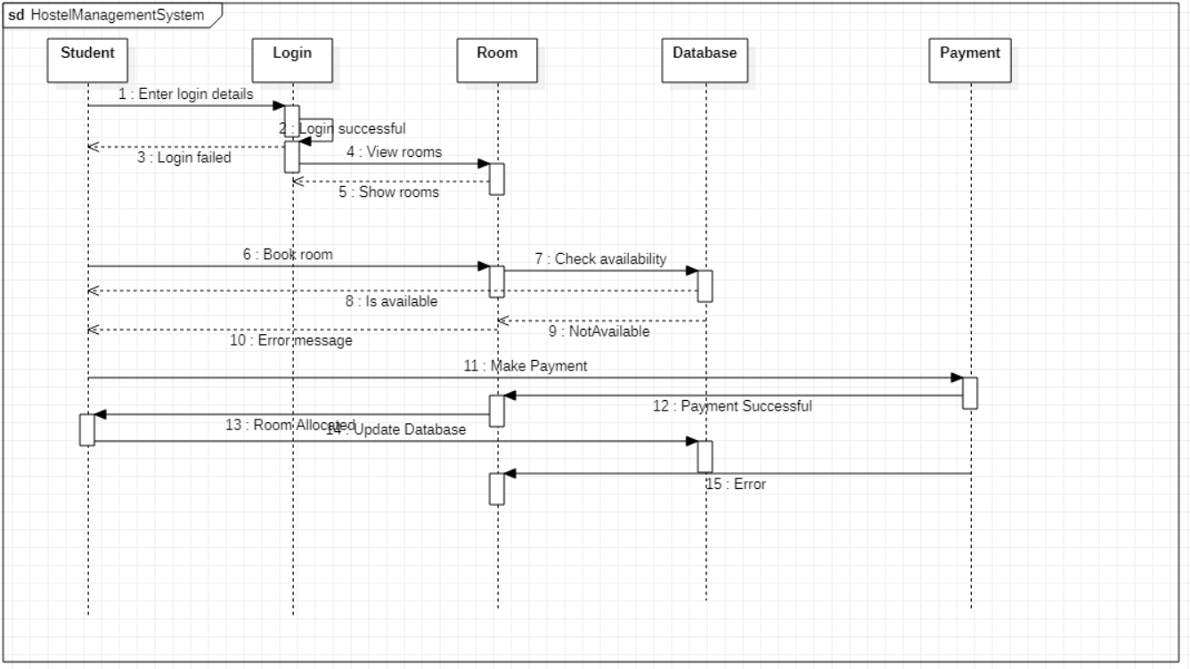

**LAB3: INVENTORY MANAGEMENT SYSTEM**

**SRS**

**Problem Statement**

The purpose of the stock management system is to insert and update items by the warehouse holder by obtaining the information from the various stock sellers, view sales and stock reports in an efficient manner.

**Software Requirement Specification**

**Functional Requirements:**

Stock maintenance system has the information of all the products and sales reports.

System provides the customer to purchase orders and make payment.

Supplier accepts the order and supplies the specified products list.

Customers can view the products and check whether the particular product is present or not.

Customers should be able to track their products.

The Supplier should be able to automatically update and generate reports regarding the stocks.

**Non-Functional Requirements:**

The database storing the details must be secure.

The database should be able to store the log records in an understandable manner.

Easy insertion, updation and retrieval of information.

ADVANCED CLASS DIAGRAM

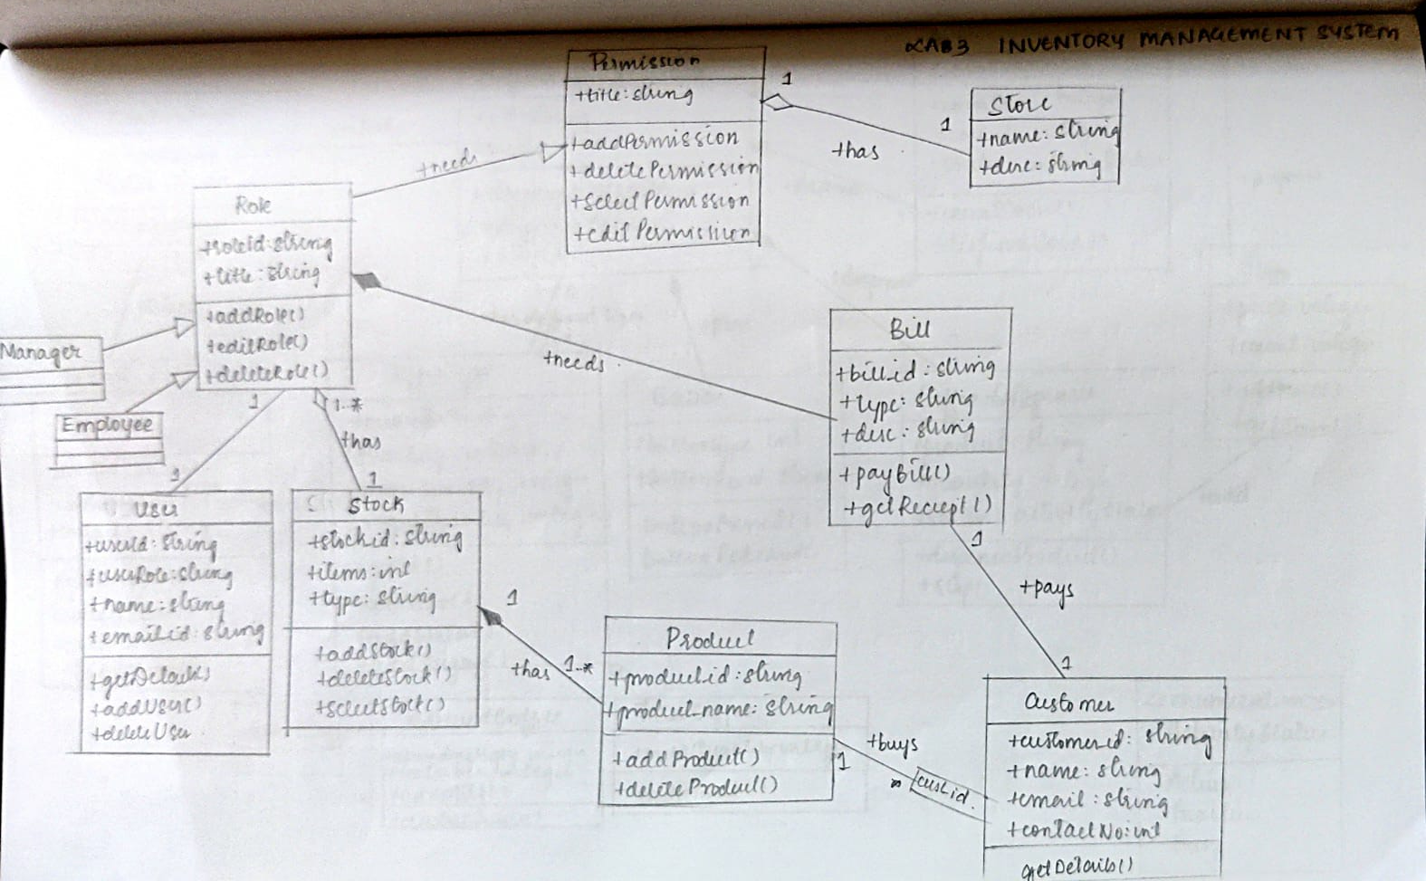

ADVANCED STATE DIAGRAM

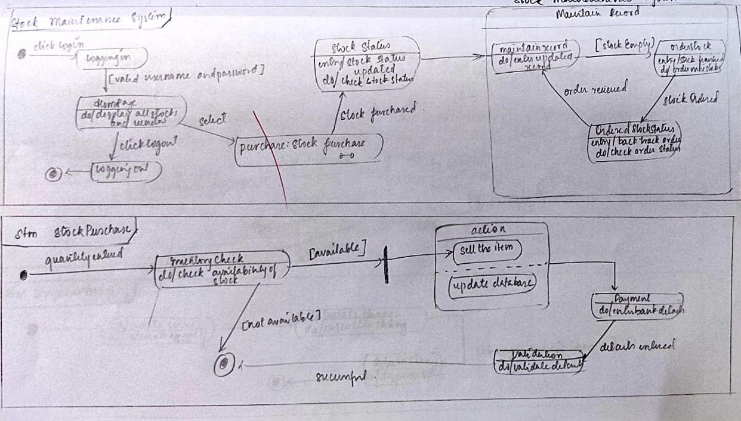

ADVANCED USE CASE DIAGRAM

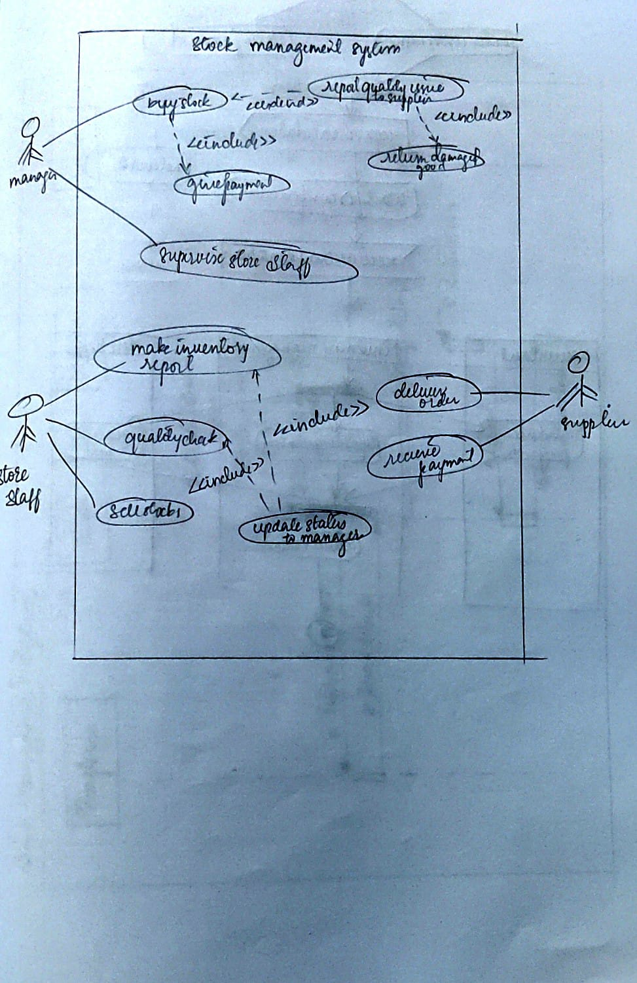

ADVANCED ACTIVITY DIAGRAM

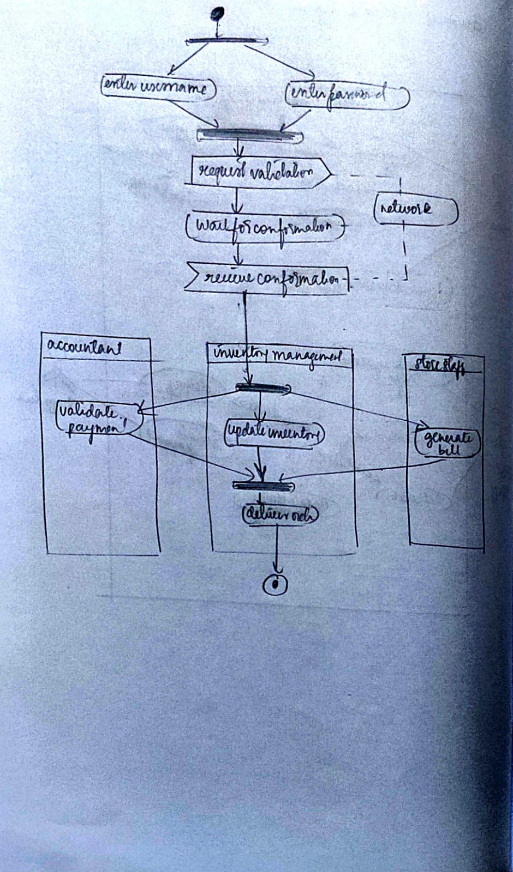

ADVANCED SEQUENCE DIAGRAM

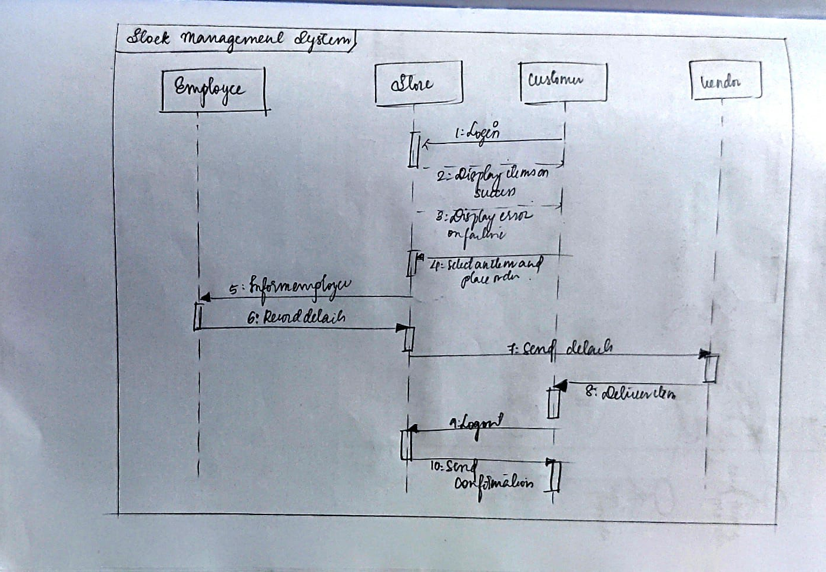

ADVANCED CLASS DIAGRAM

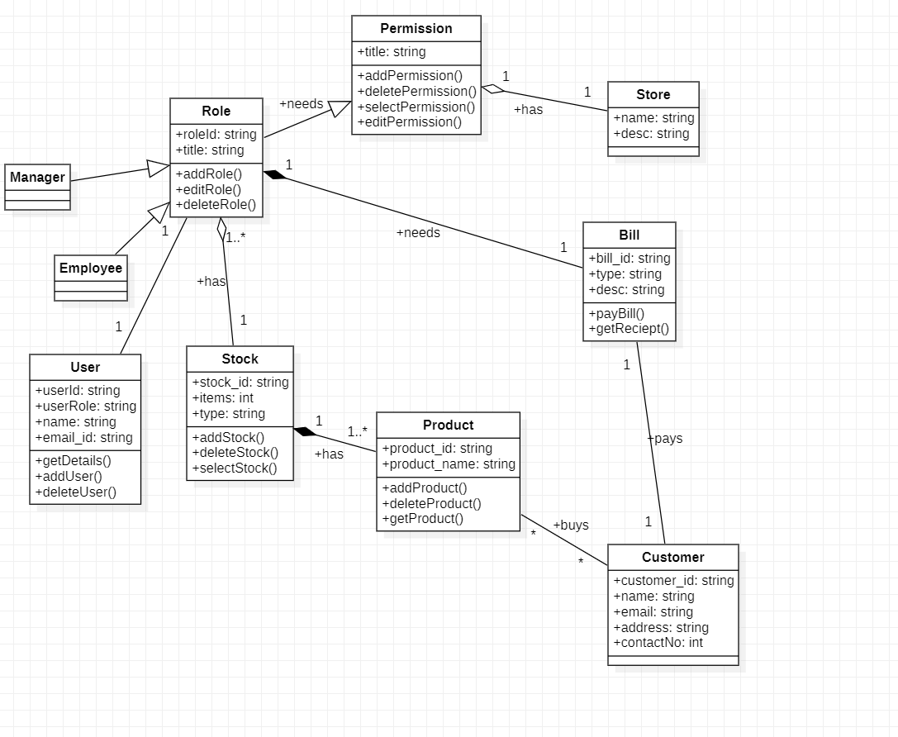

ADVANCED STATE DIAGRAM

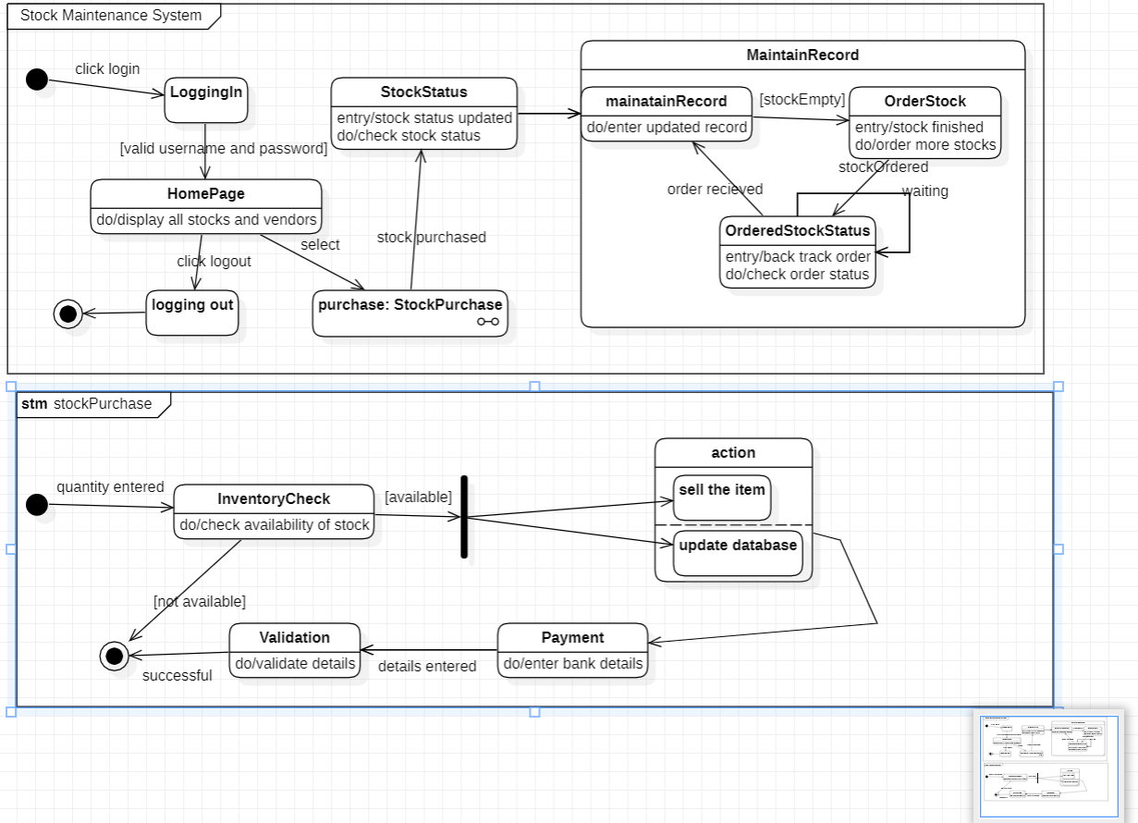

8

ADVANCED USE CASE DIAGRAM

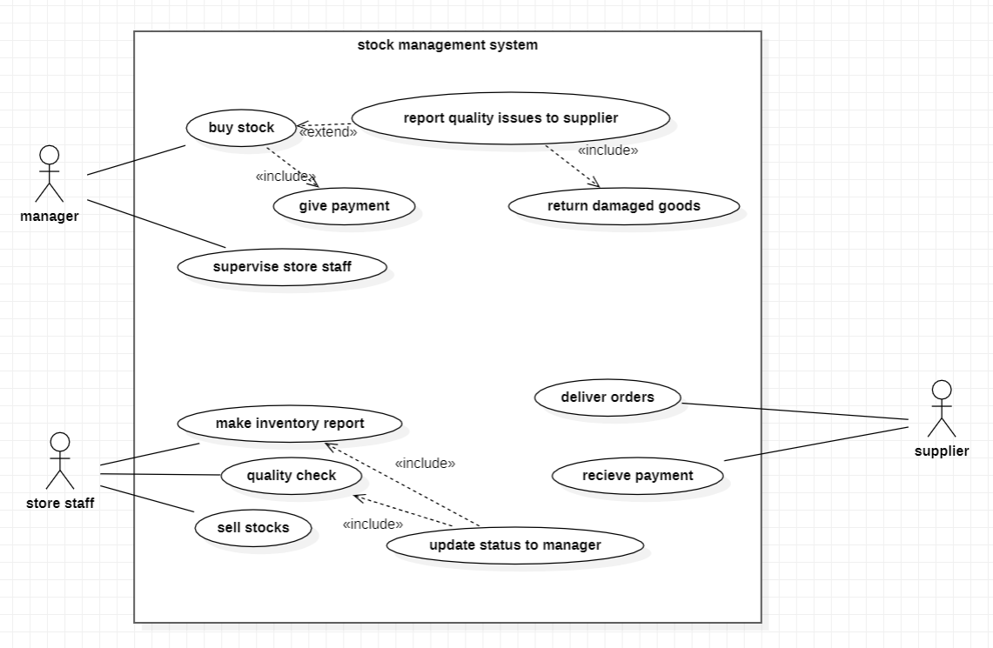

ADVANCED ACTIVITY DIAGRAM

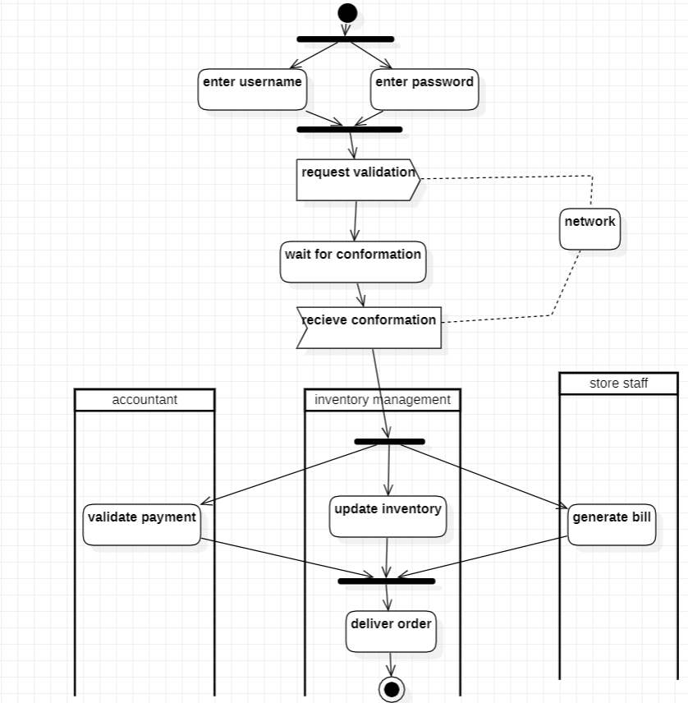

ADVANCED SEQUENCE DIAGRAM

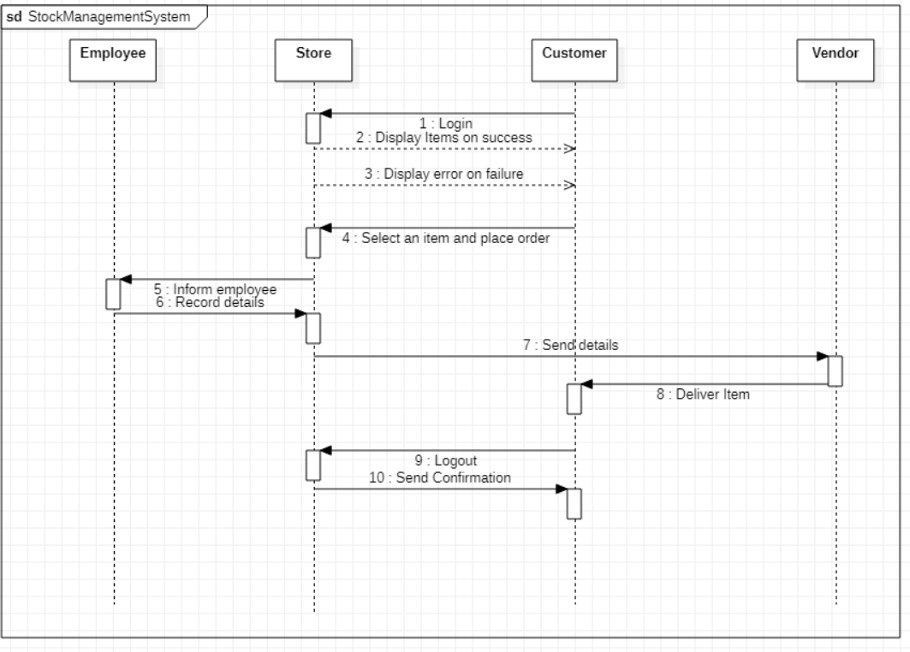

**LAB4: COFFEE VENDING MACHINE**

**SRS**

**Problem Statement**

A coffee vending machine that dispenses coffee to the users after selecting the type of coffee and making the payment. The vending machine must provide different types of coffee and should provide a suitable interface for placing an order and payment system.

**System Requirements Specification**

**Functional Requirements:**

System can be accessible by only those persons with visual and touch capabilities

System displays a menu containing the various products offered by the machine.

The system provides various information about the products and nutritional facts.

System has a built-in payment interface for capturing payments and generating bills.

System dispenses selected product on completion of payment.

**Non-Functional Requirements:**

The system should be developed within the budget specified.

The payment gateway should be secured.

ADVANCED CLASS DIAGRAM

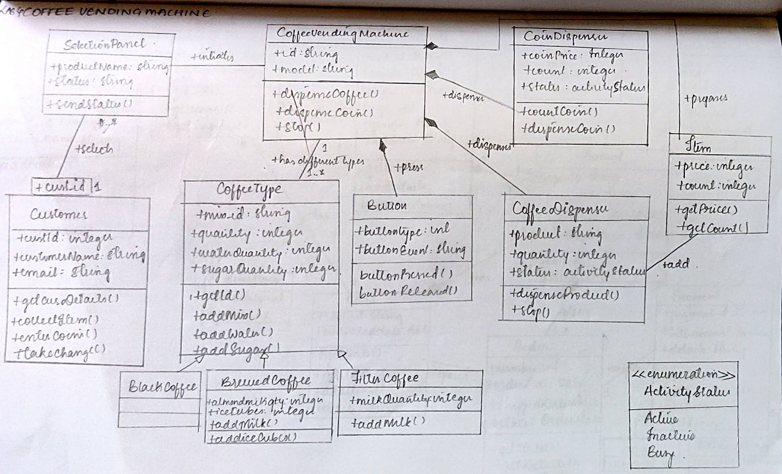

ADVANCED STATE DIAGRAM

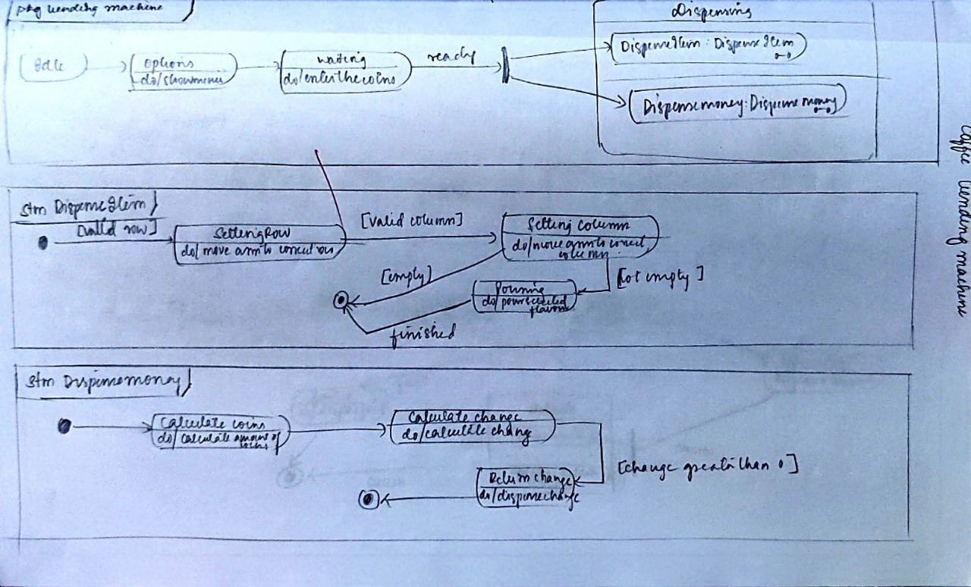

ADVANCED USE CASE DIAGRAM

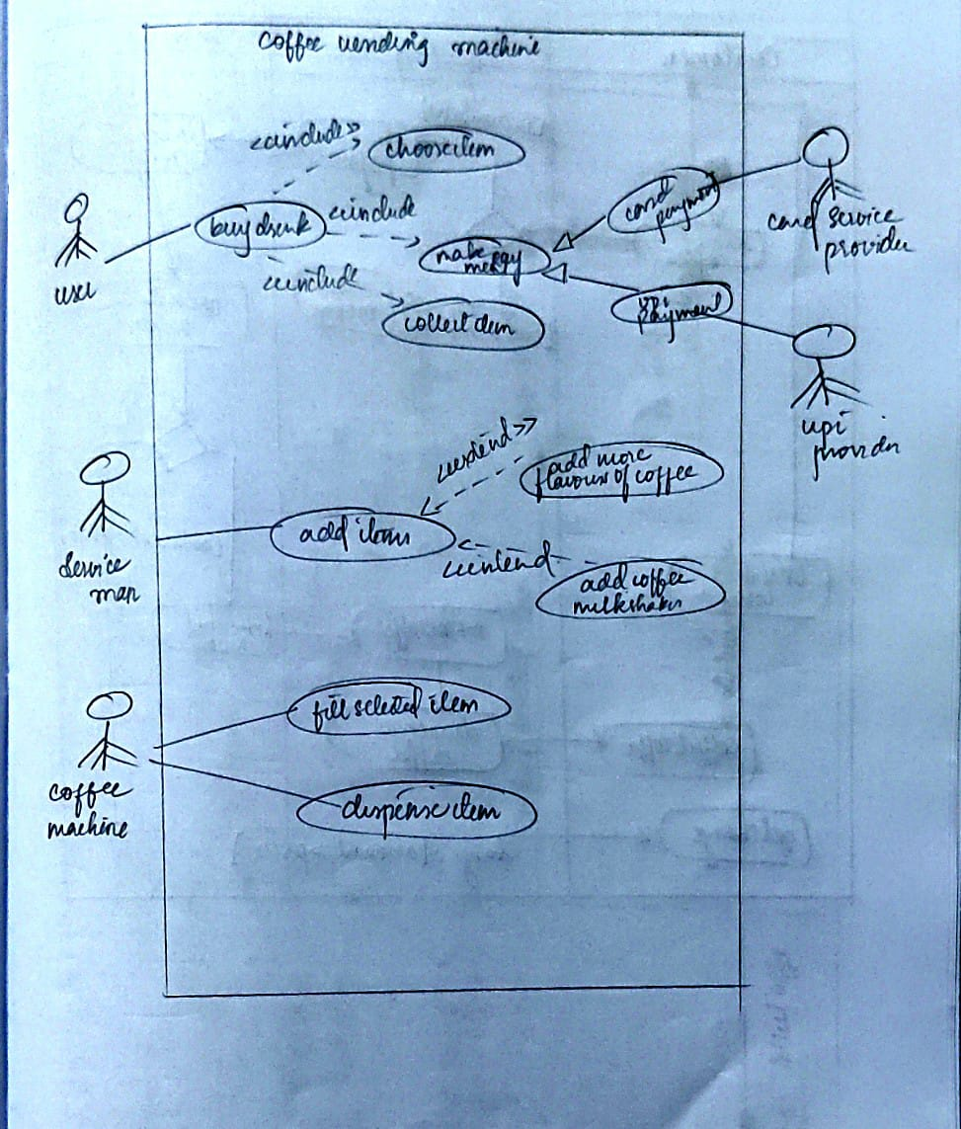

ADVANCED ACTIVITY DIAGRAM

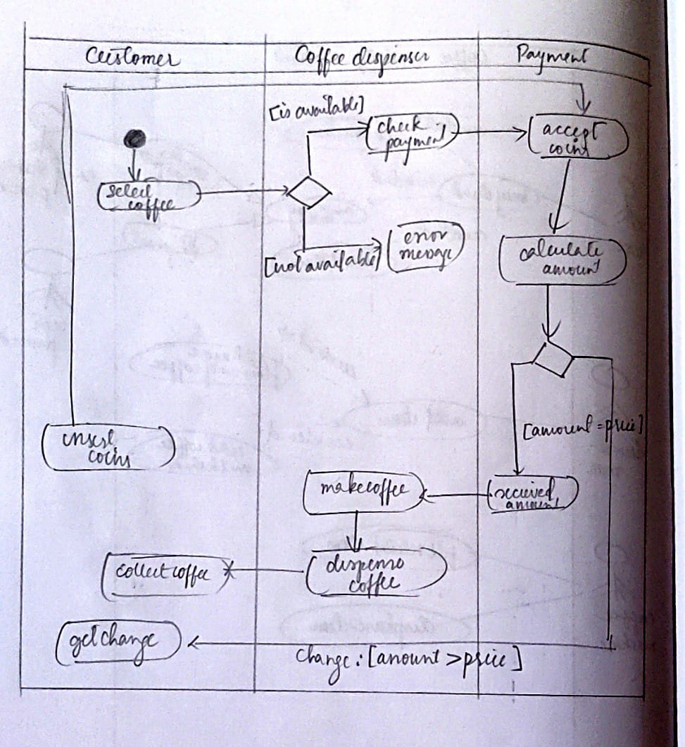

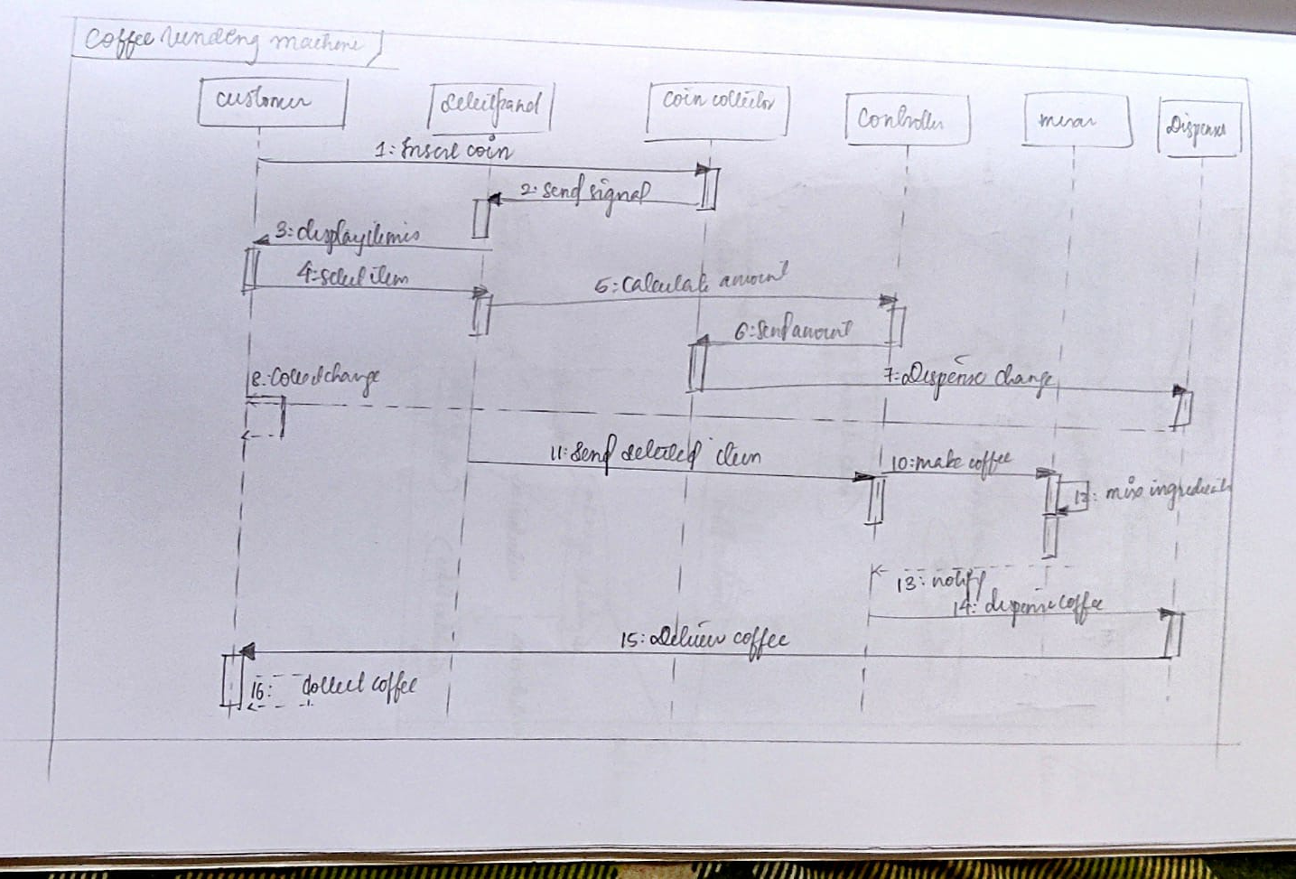ADVANCED SEQUENCE DIAGRAM

ADVANCED CLASS DAIGRAM

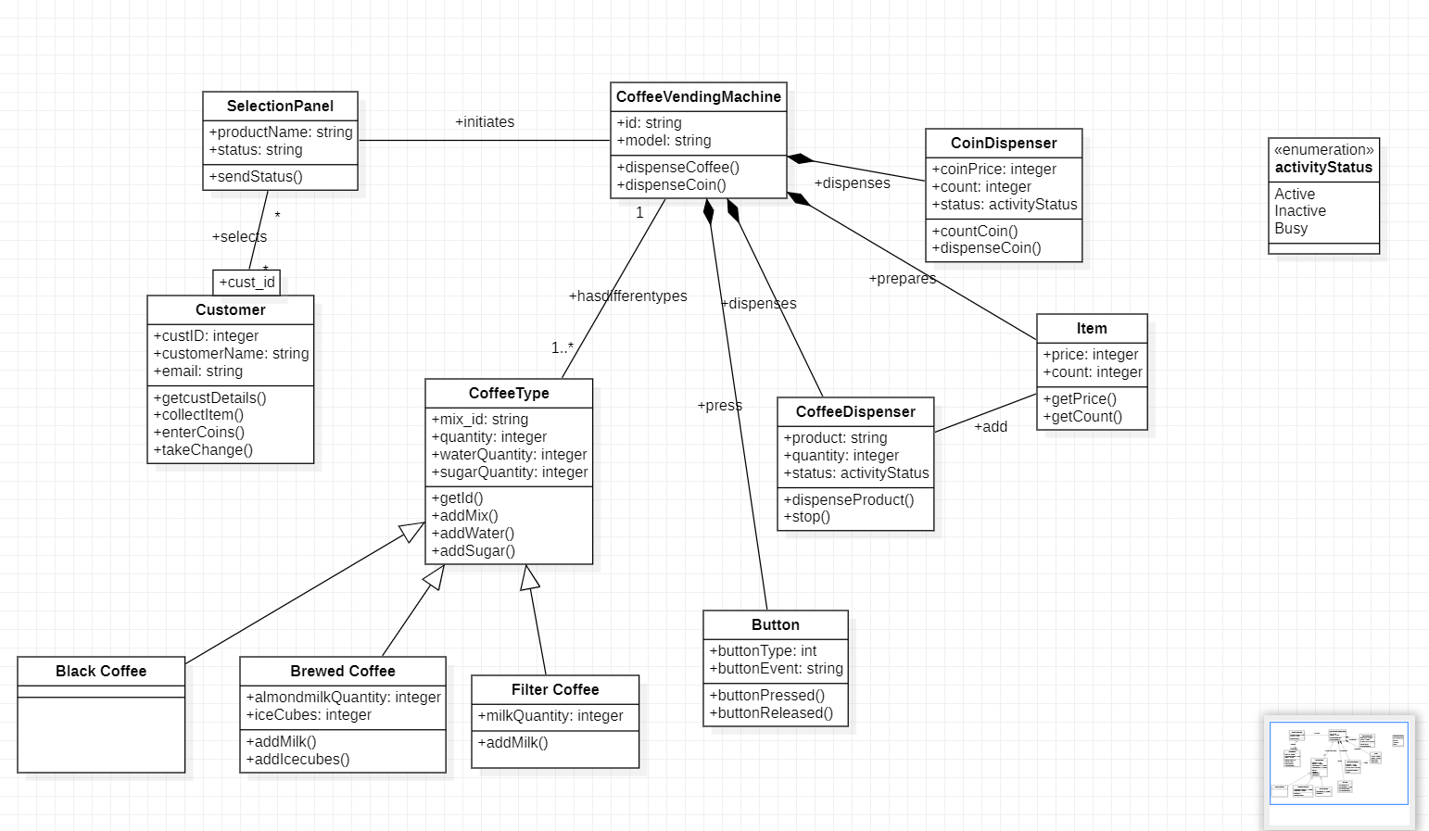

ADVANCED STATE DIAGRAM

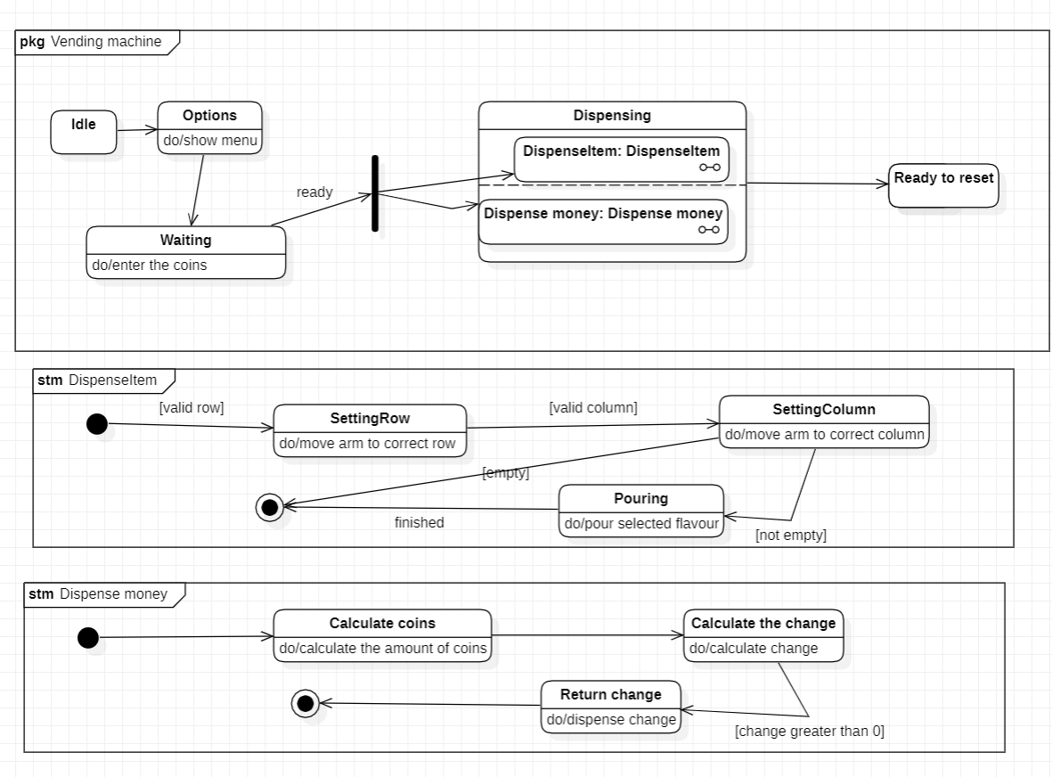

ADVANCED USE CASE DIAGRAM

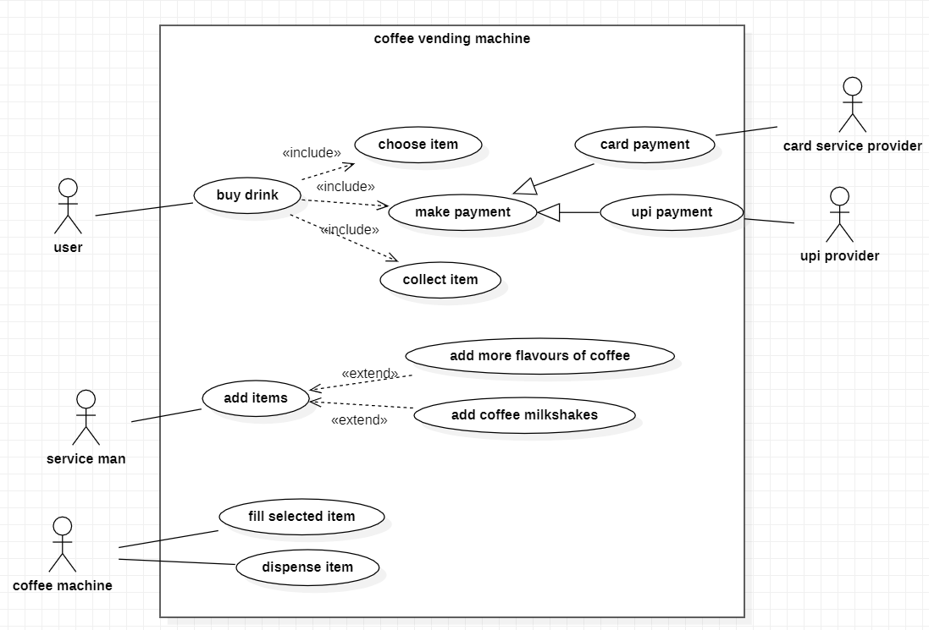

ADVANCED ACTIVITY DIAGRAM

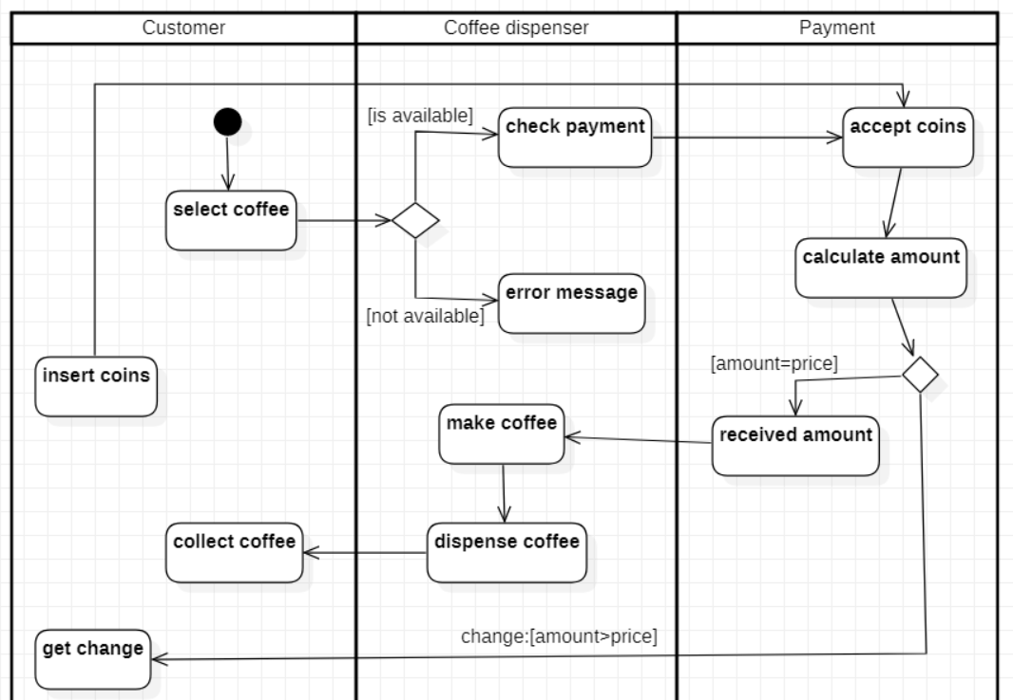

ADVANCED SEQUENCE DIAGRAM

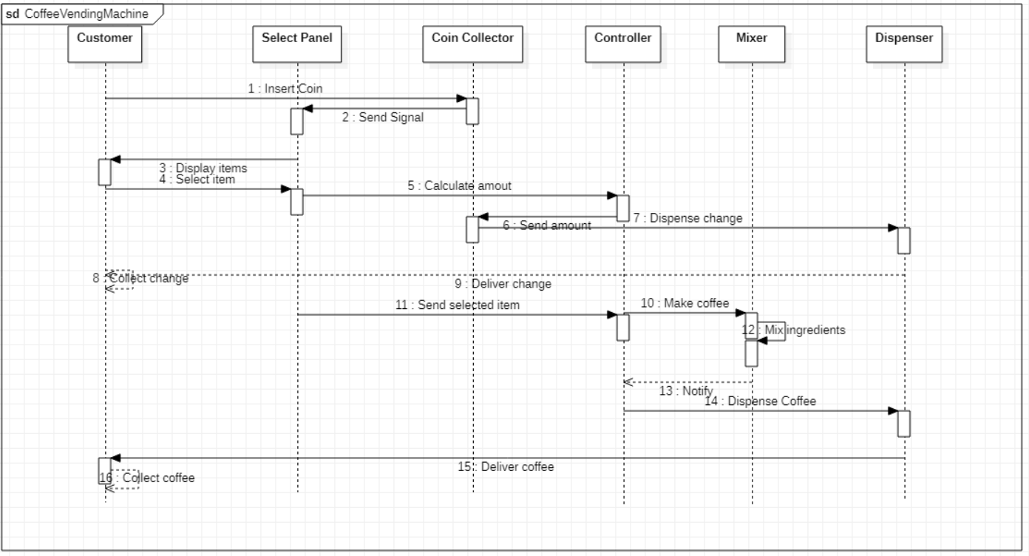

**LAB5: ONLINE SHOPPING SYSTEM**

**SRS**

**Problem Statement**

An online shopping mobile/web application where the vendors can advertise their products on the portal and users can choose their product they want to buy. The system offers various payment methods.

**System Requirement Specification**

**Functional Requirements:**

Customers can browse through products by category.

Portal includes a recommendation system to suit customers.

Vendors can add their products with description and their price.

Vendors can view orders and the date of product pickup by the delivery agency.

The customers can add items to cart or save them for later purchase.

Portal will include a mechanism to track delivery of the products.

Customers can choose their desired mode of shipping and location.

**Non-Functional Requirement:**

The system should be developed within the budget specified.

The database should be secure.

ADVANCED CLASS DIAGRAM

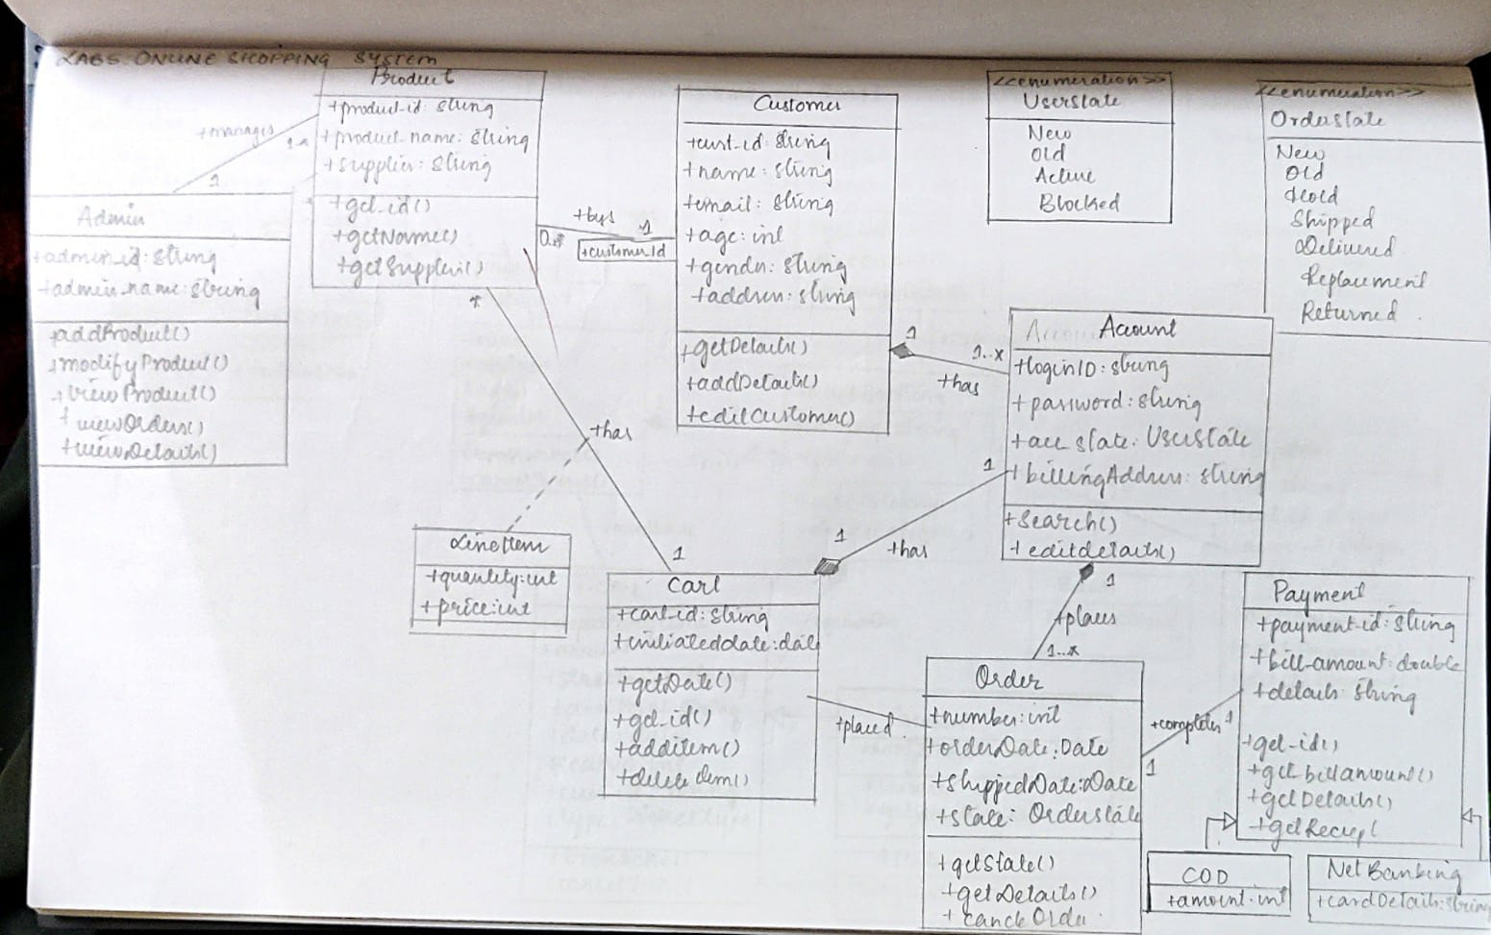

ADVANCED STATE DIAGRAM

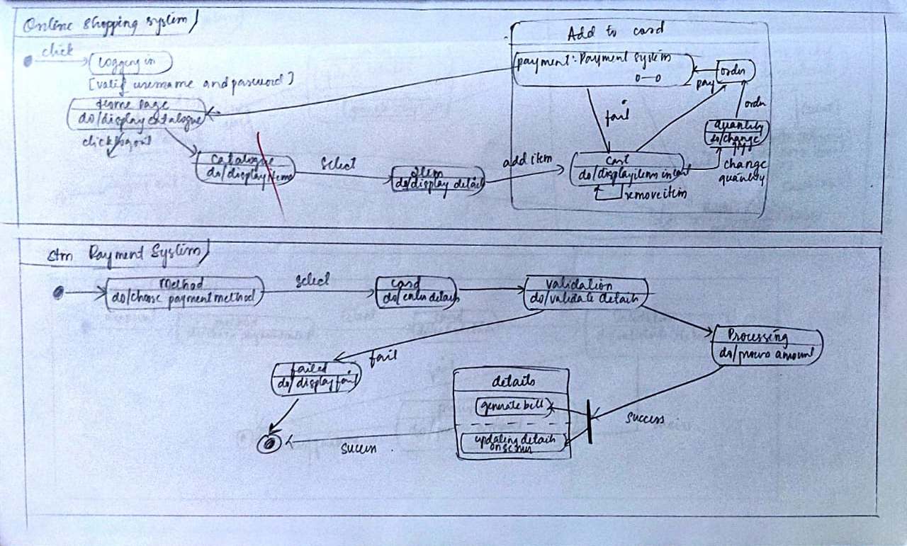

ADVANCED USE CASE DIAGRAM

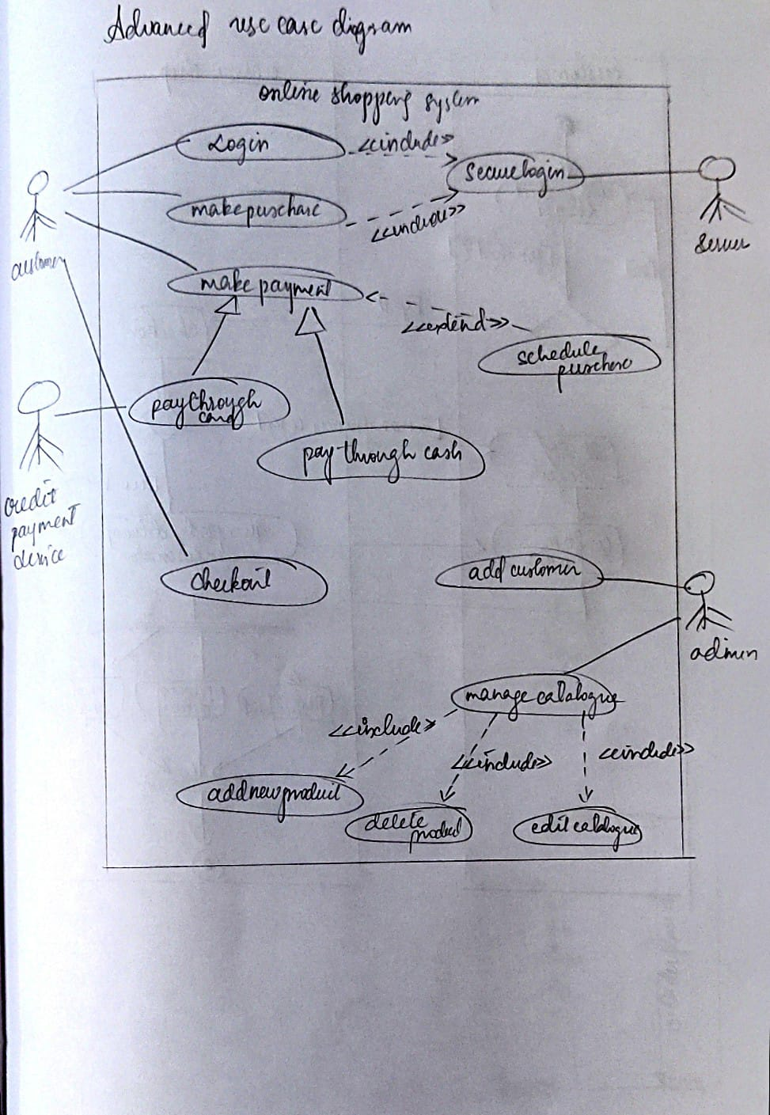

ADVANCED ACTIVITY DIAGRAM

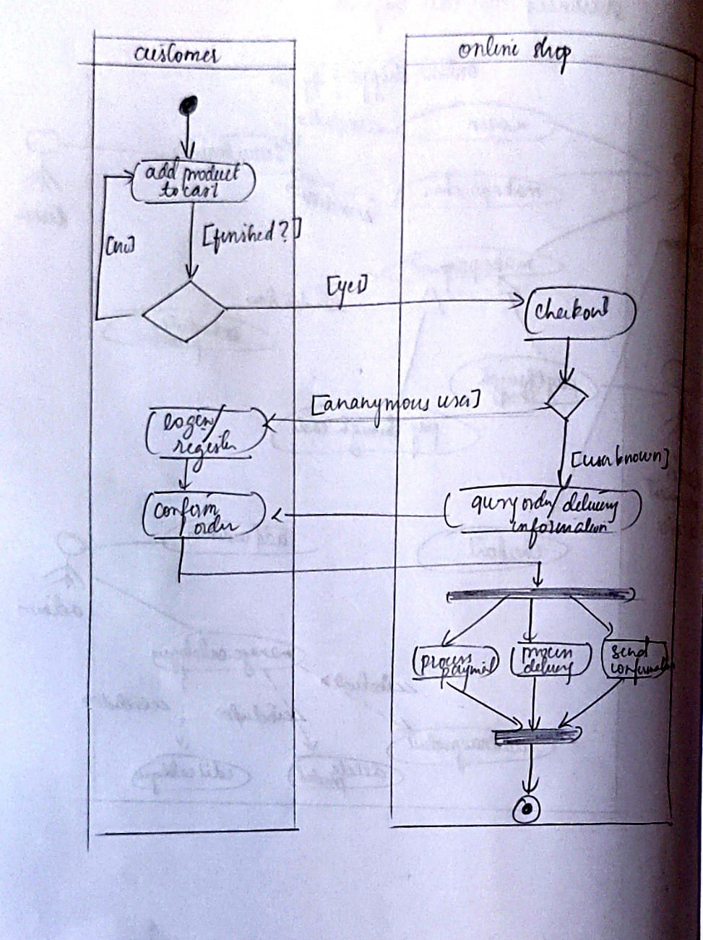

ADVANCED SEQUENCE DIAGRAM

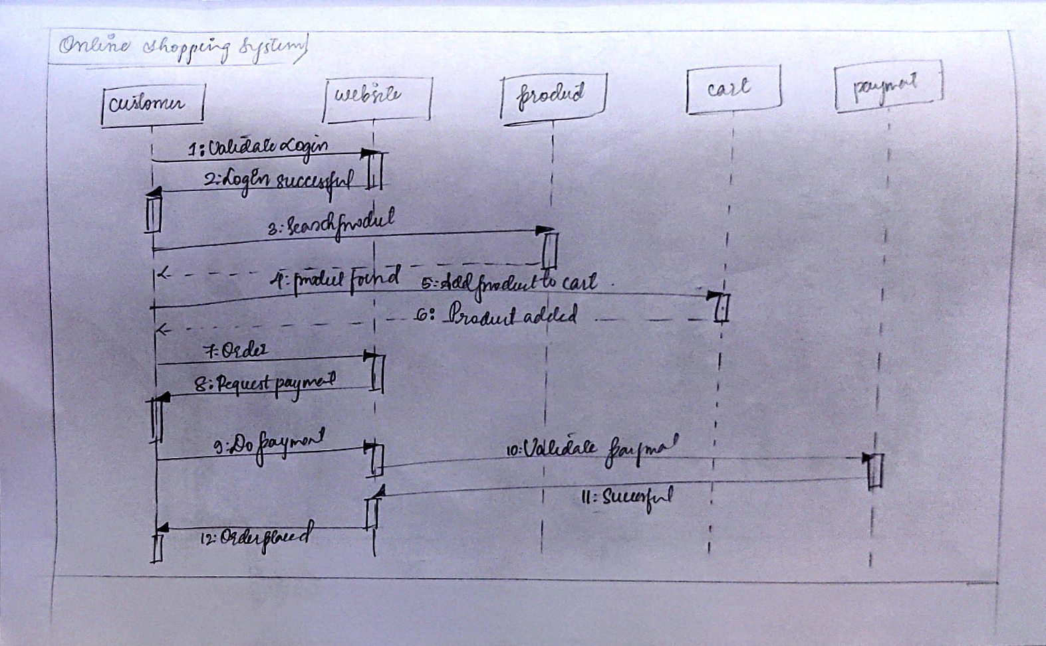

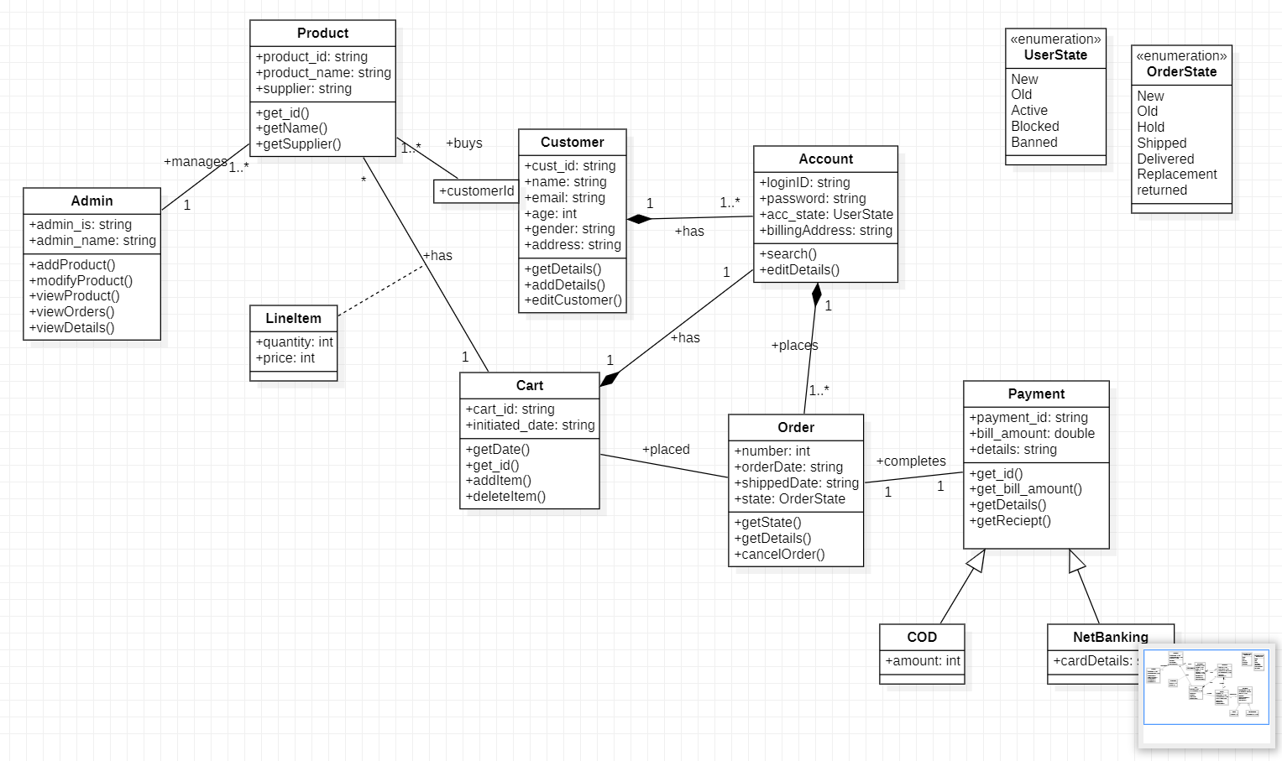ADVANCED CLASS DIAGRAM

ADVANCED STATE DIAGRAM

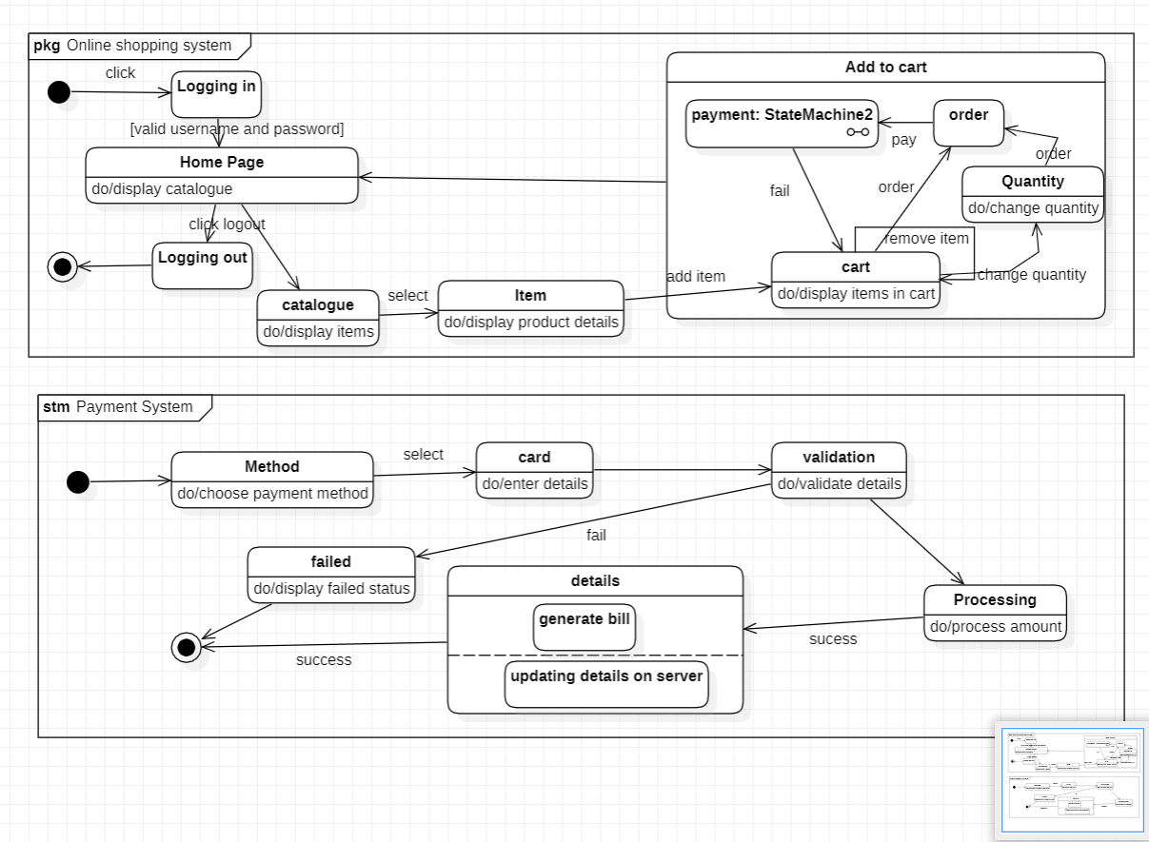

ADVANCED USE CASE DIAGRAM

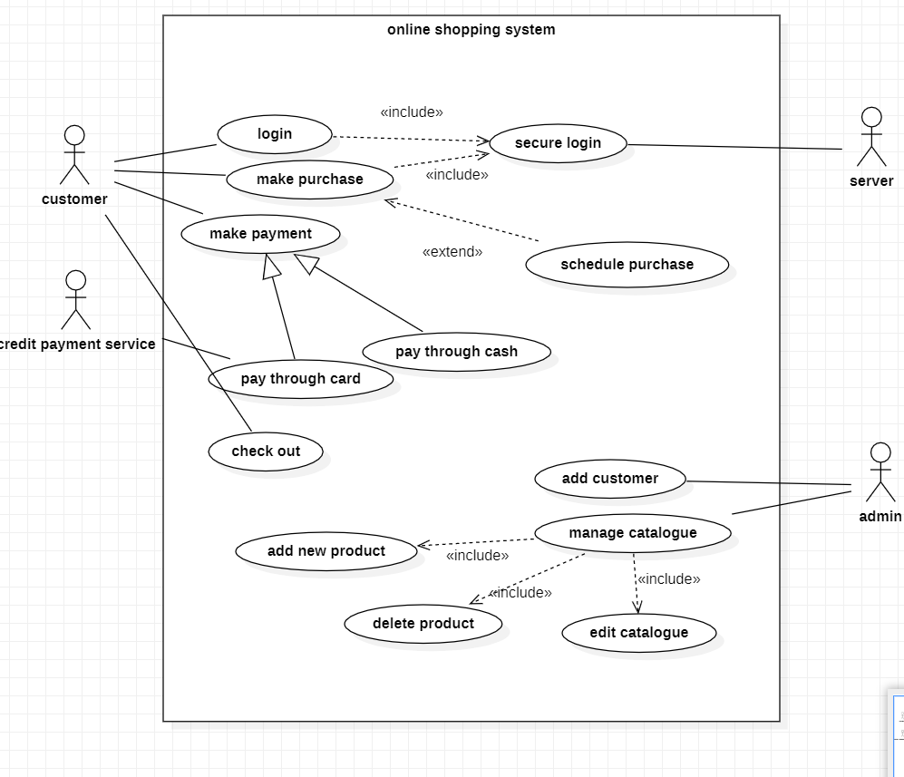

ADVANCED ACTIVITY DIAGRAM

6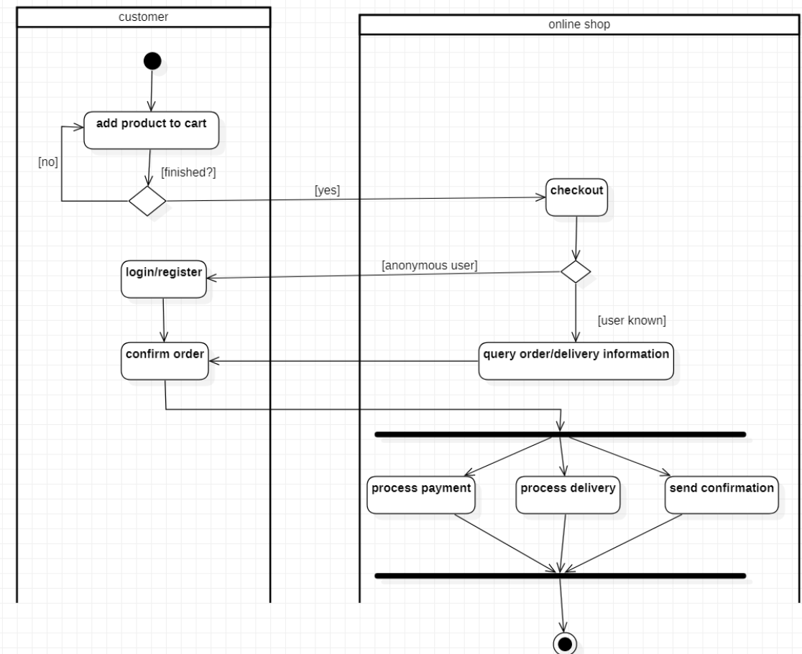

ADVANCED SEQUENCE DIAGRAM

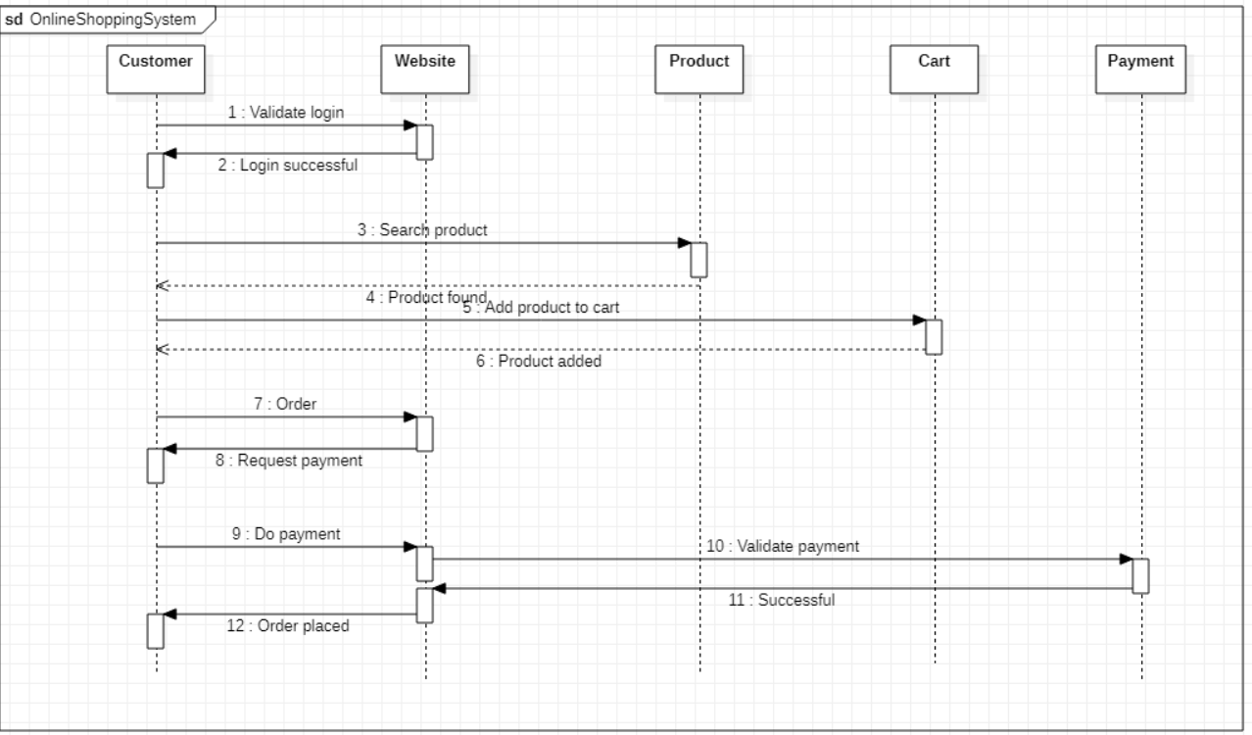

**LAB6: RAILWAY MANAGEMENT SYSTEM**

**SRS**

**Problem Statement**

To develop a user-friendly Railway Reservation system to enable passengers to book tickets online and make online payments.

**System Requirement Specification**

**Functional Requirements:**

System provides train timing details, reservation, billing and cancellation on various types of reservations.

System enables advanced booking in any class, against general and ladies quota and any number of seats can be booked and cancelled.

System provides the details about the timetable, train fares, current status of reservation position.

Login/Signup of admin using credentials for updating the train chart.

Options to reserve or cancel tickets.

A screen which records all user transactions and secure payment methods.

**Non-Functional Requirements:**

The database should be secure.

The system should be robust.

The system should be developed within the budget specified.

ADVANCED CLASS DIAGRAM

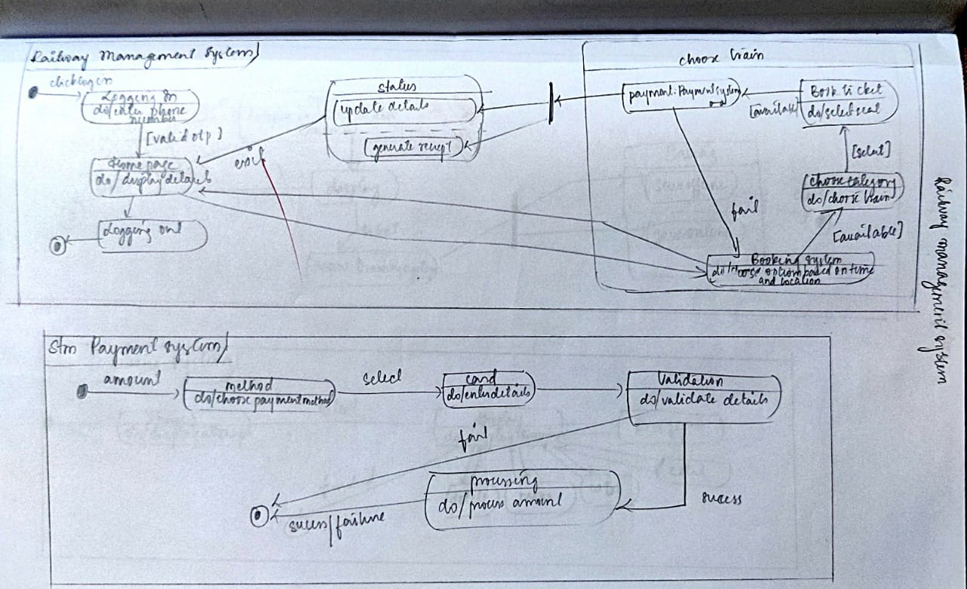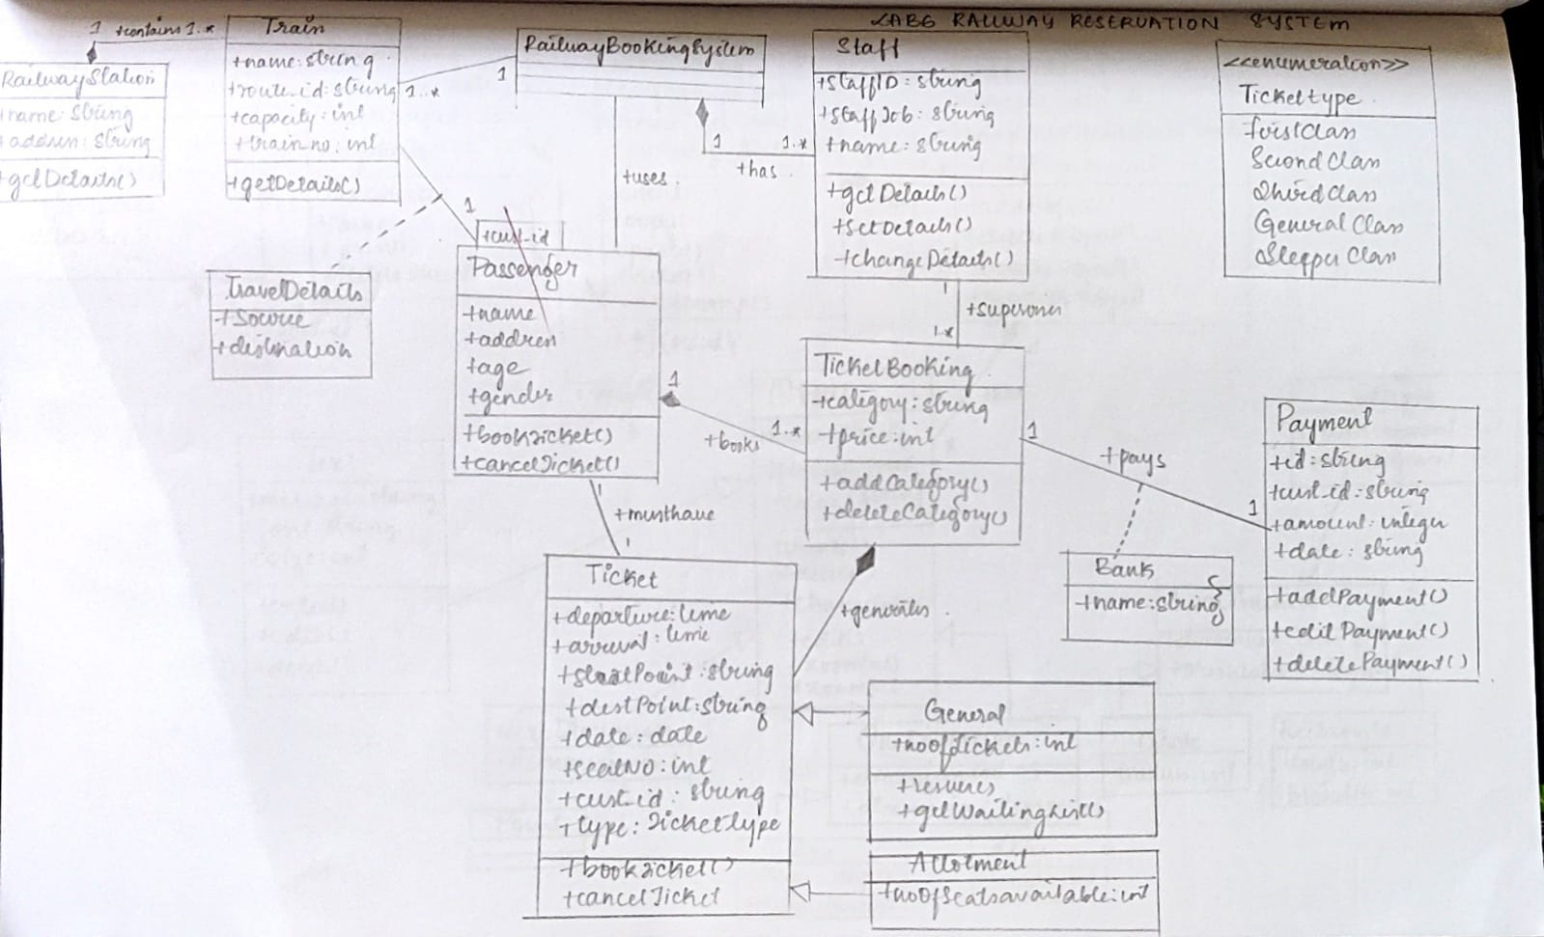

ADVANCED STATE DIAGRAM

ADVANCED USE CASE DIAGRAM

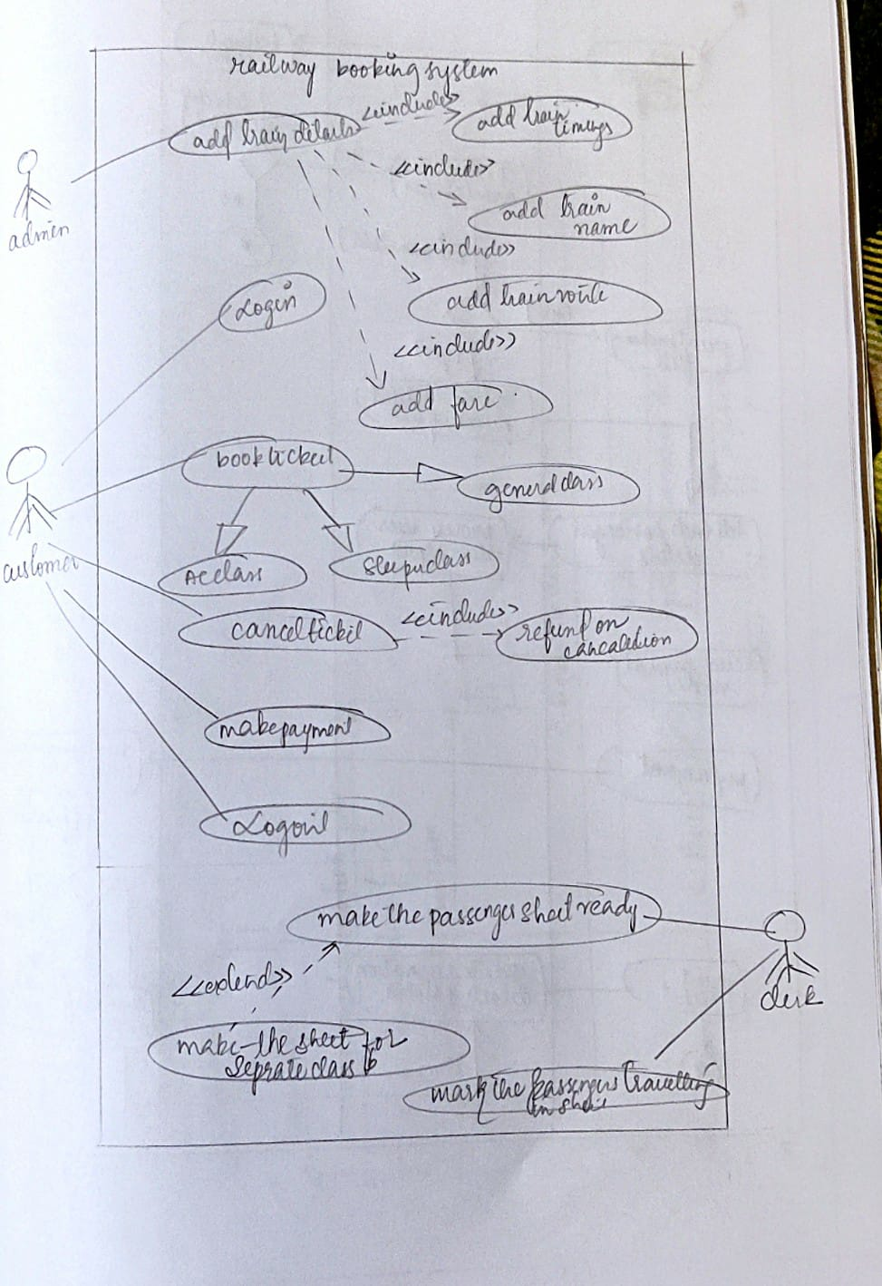

ADVANCED ACTIVITY DIAGRAM

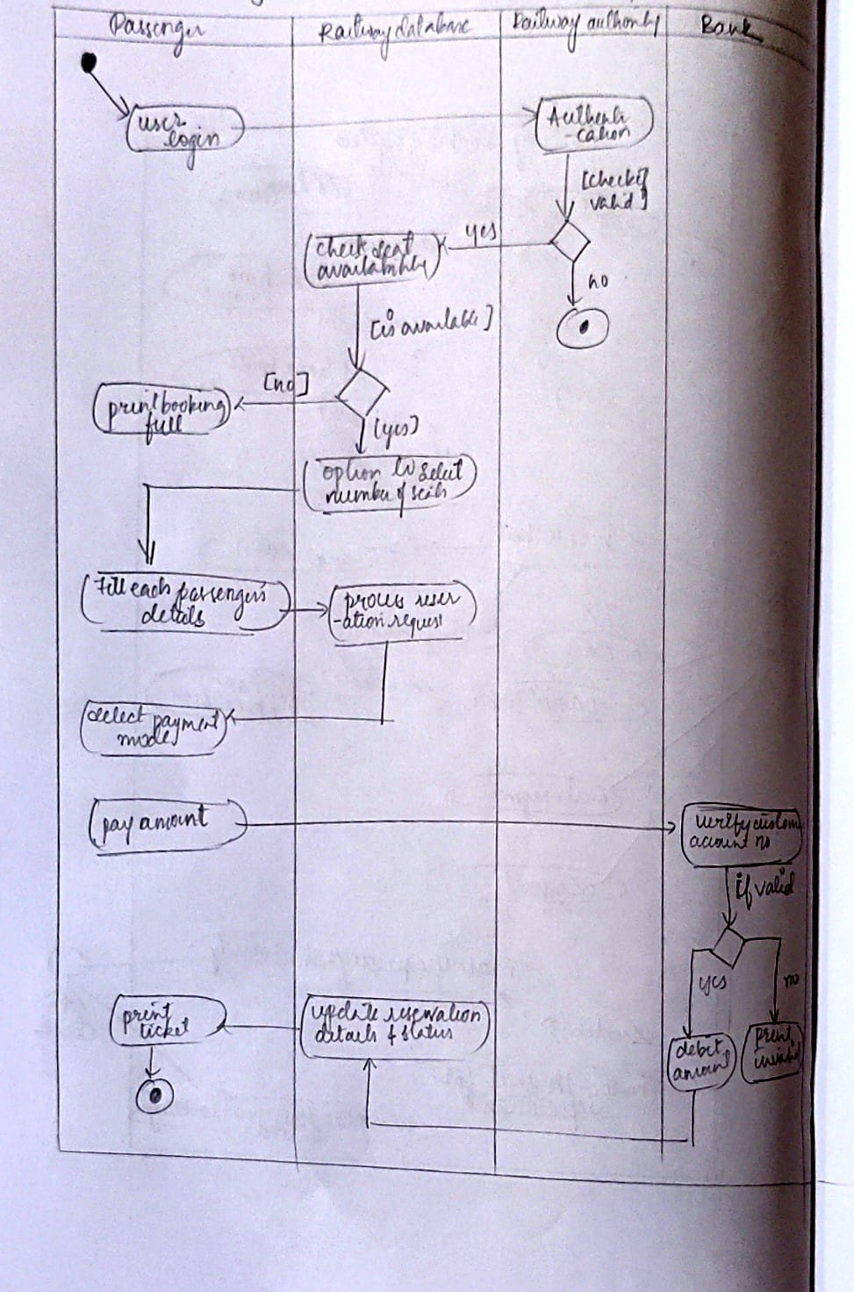

ADVANCED SEQUENCE DIAGRAM

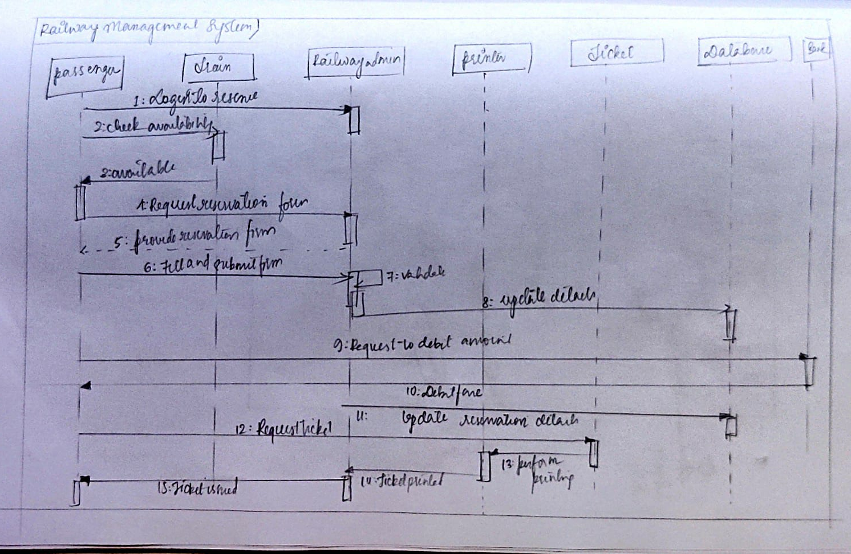

ADVANCED CLASS DIAGRAM

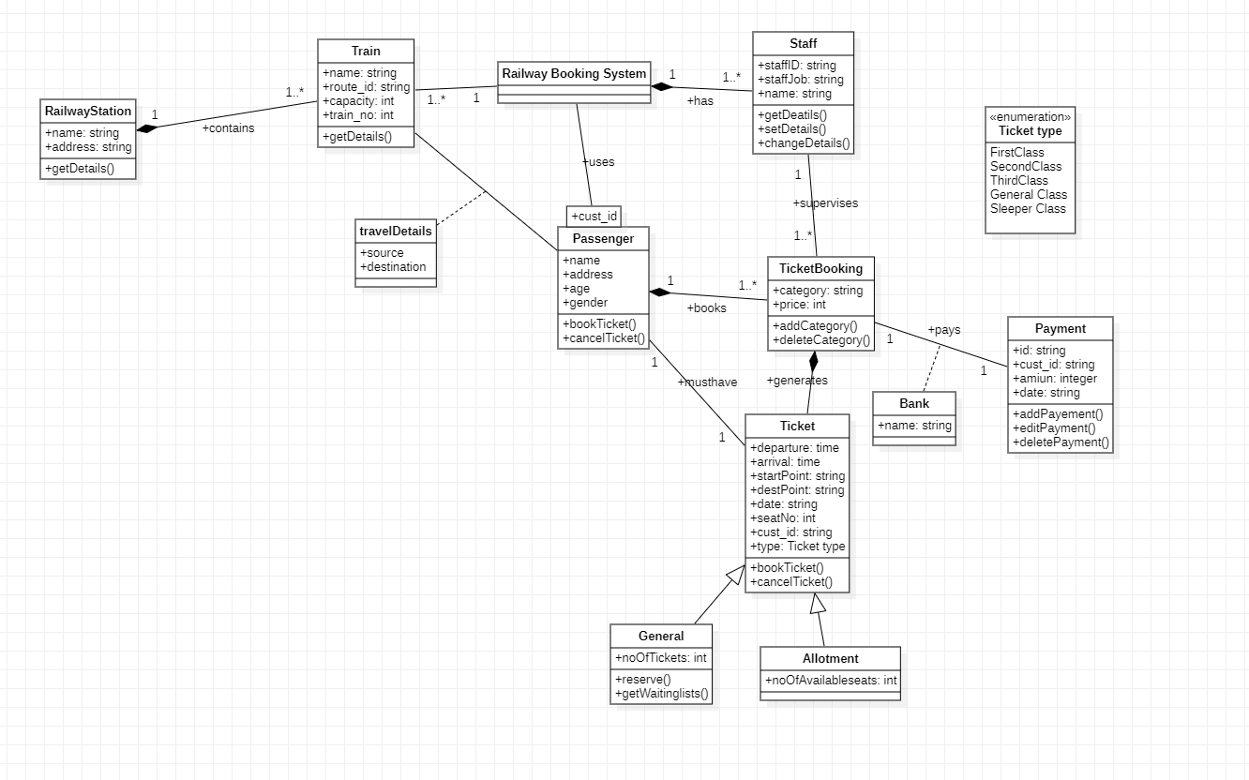

ADVANCED STATE DIAGRAM

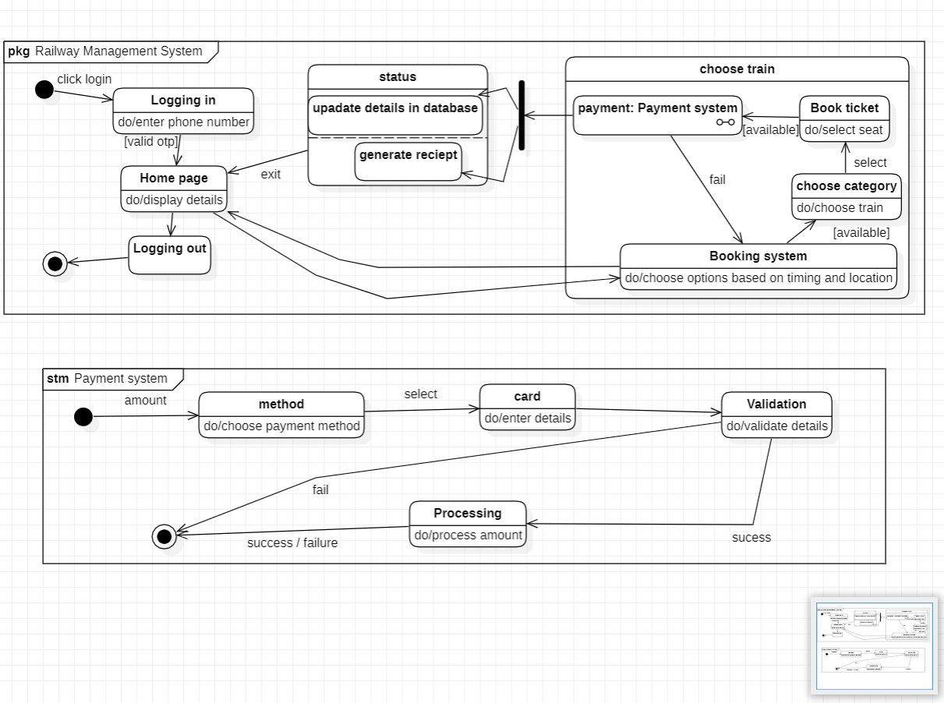

ADVANCED USE CASE DIAGRAM

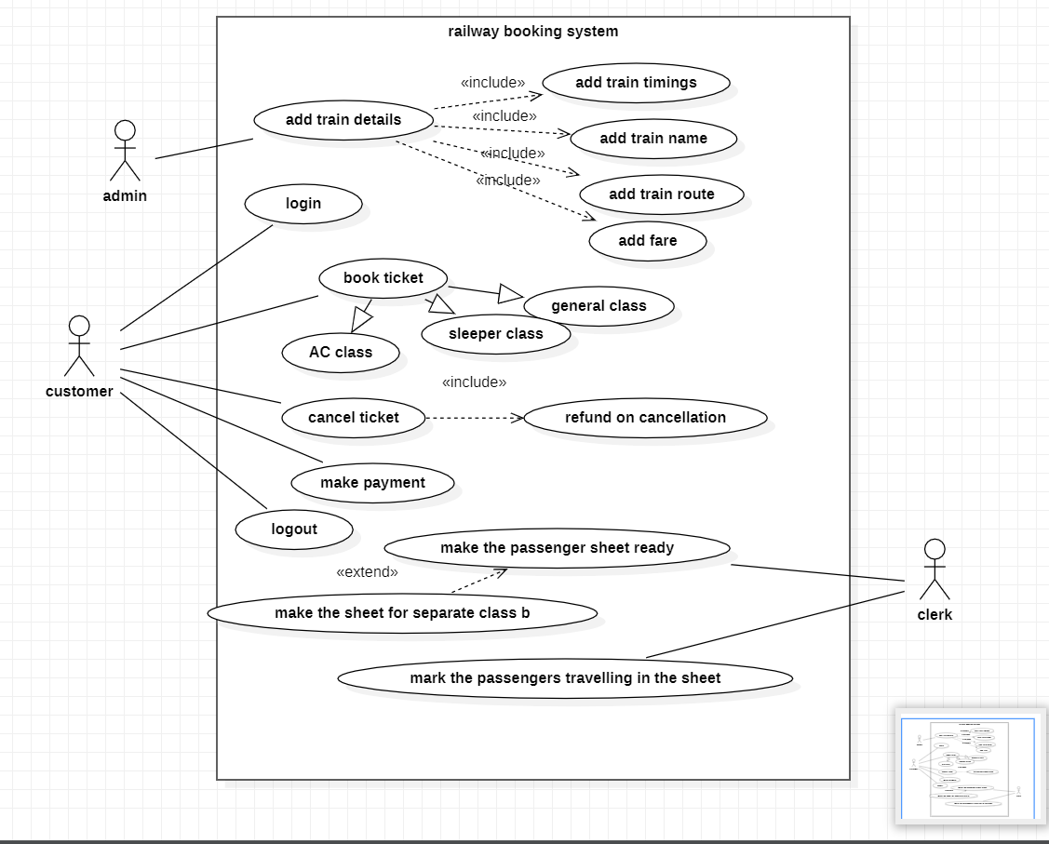

ADVANCED ACTIVITY DIAGRAM

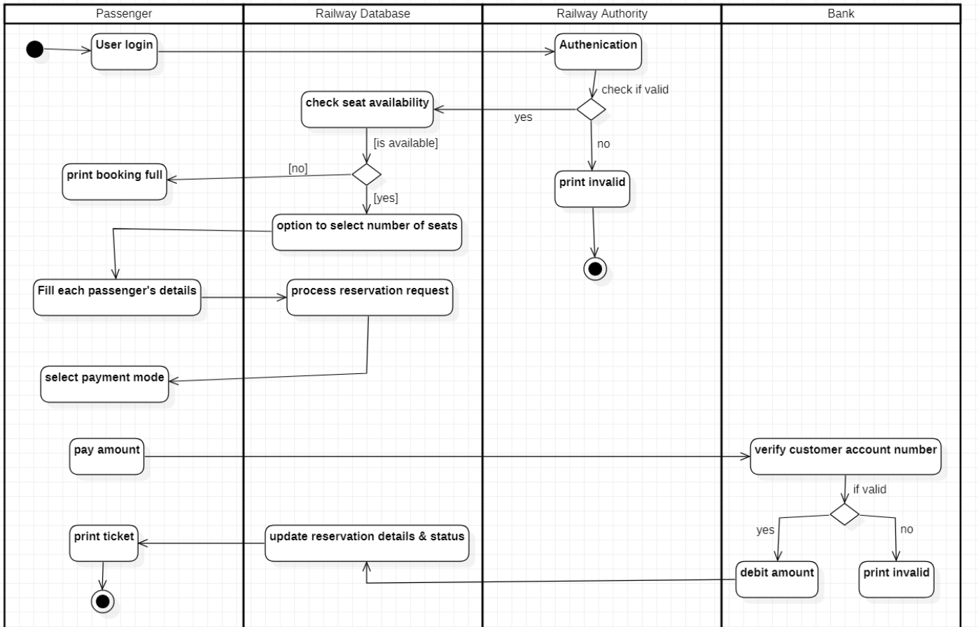

ADVANCED SEQUENCE DIAGRAM

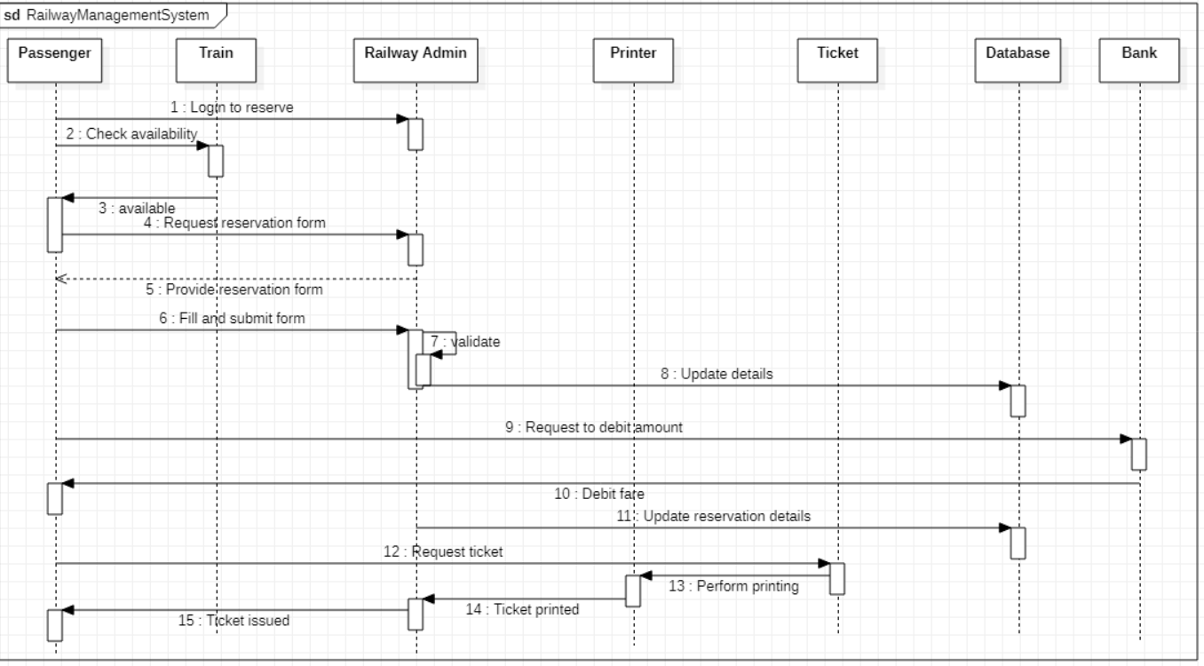

**LAB7: GRAPHICS EDITOR SYTEM**

**SRS**

**Problem Statement**

Graphics editor system enables easy ways of making and manipulating images from scratch. This tool can be included into another application which requires a graphics editor or be used independently. The editor allows user to create various graphical documents. The editor offers a wide range of tools not limited to different shapes, colors etc.

**System Requirement Specification**

**Functional Requirements.**

The editor helps users draw figures from scratch or manipulate the existing ones.

Editor can be included in applications which require a graphics editor or be used independently.

Editor offers various tools like line, shapes, colors, file effects etc which aid in hassle free drawing.

A document may have many sheets each consisting of various figures and can also contain textual information.

The editor facilitates manipulation of images which includes changing saturation exposure.

Documents can be exported as pdf, svg, png, jpg or other forms.

ADVANCED CLASS DIAGRAM

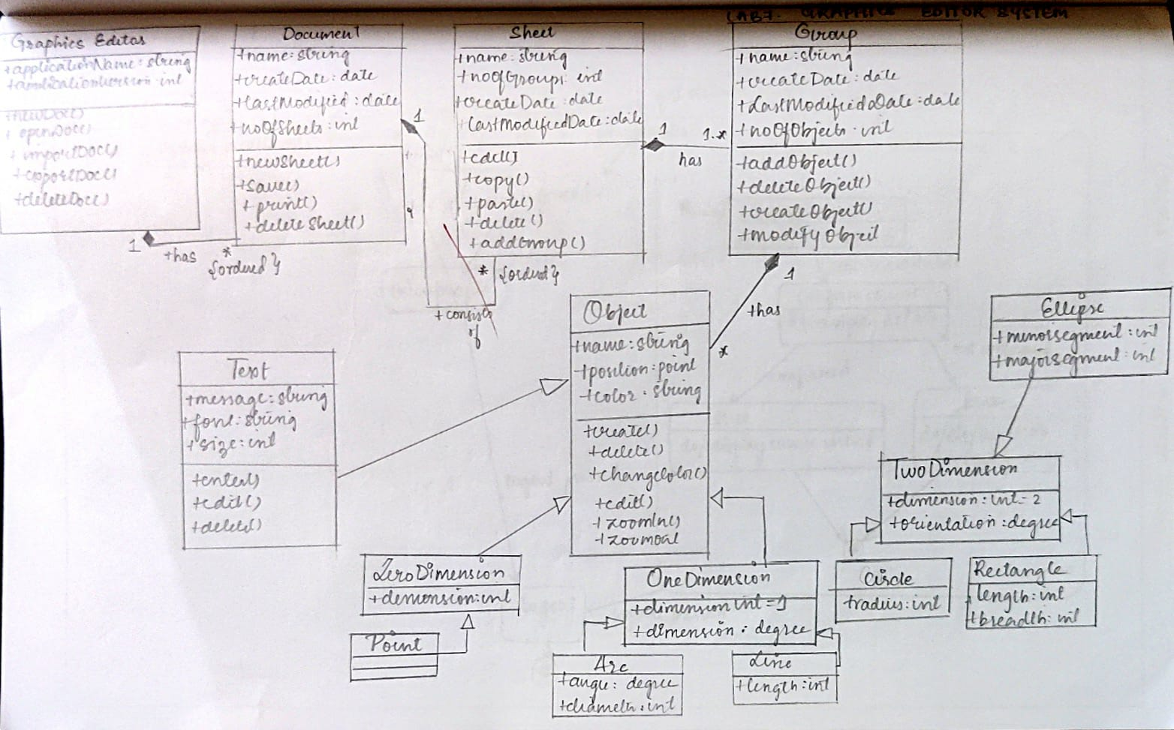

ADVANCED STATE DIAGRAM

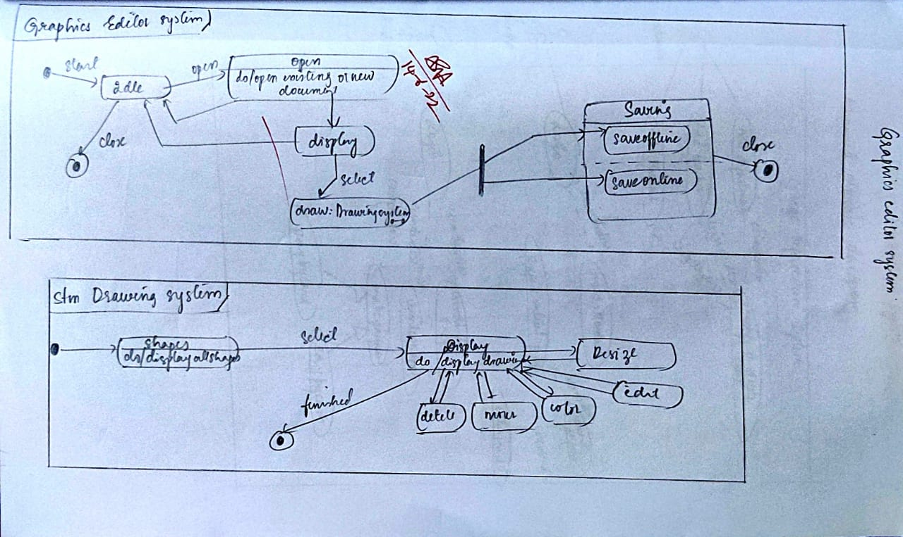

ADVANCED USE CASE DIAGRAM

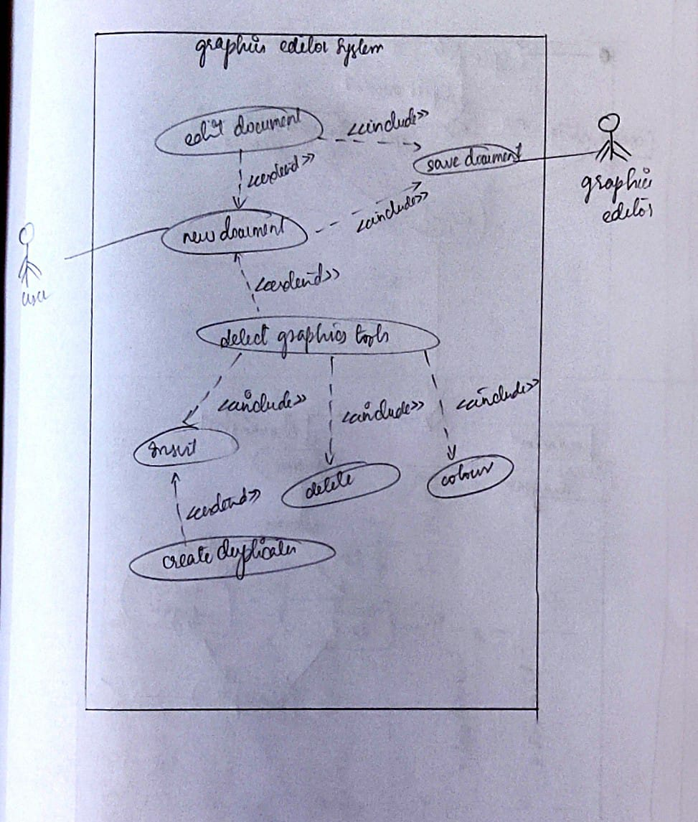

ADVANCED ACTIVITY DIAGRAM

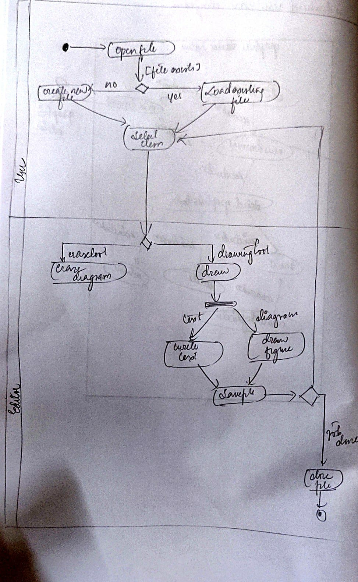

ADVANCED SEQUENCE DIAGRAM

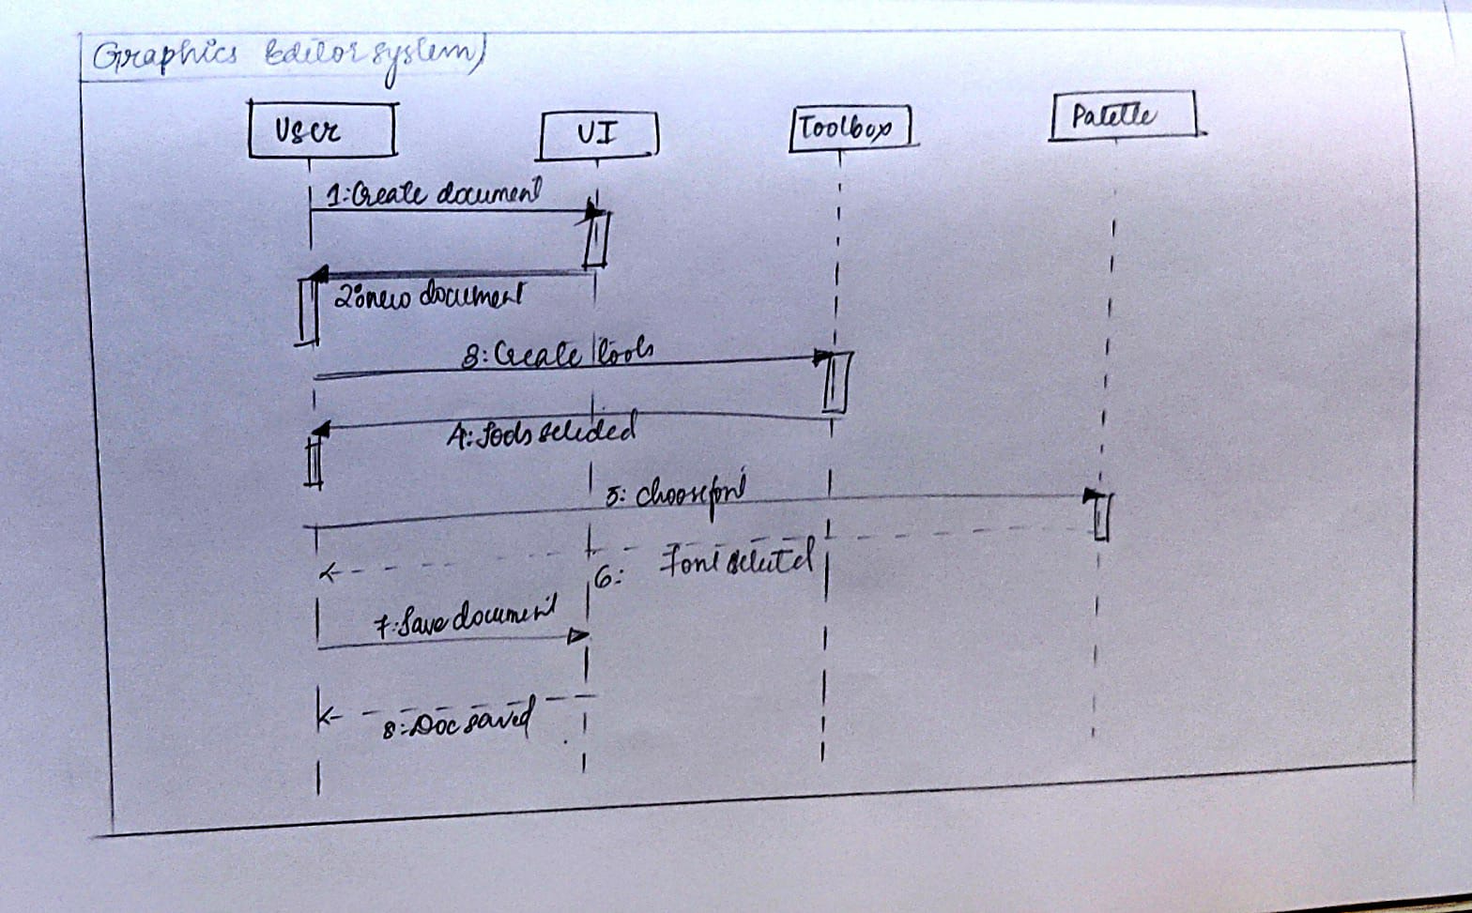

ADVANCED CLASS DIAGRAM

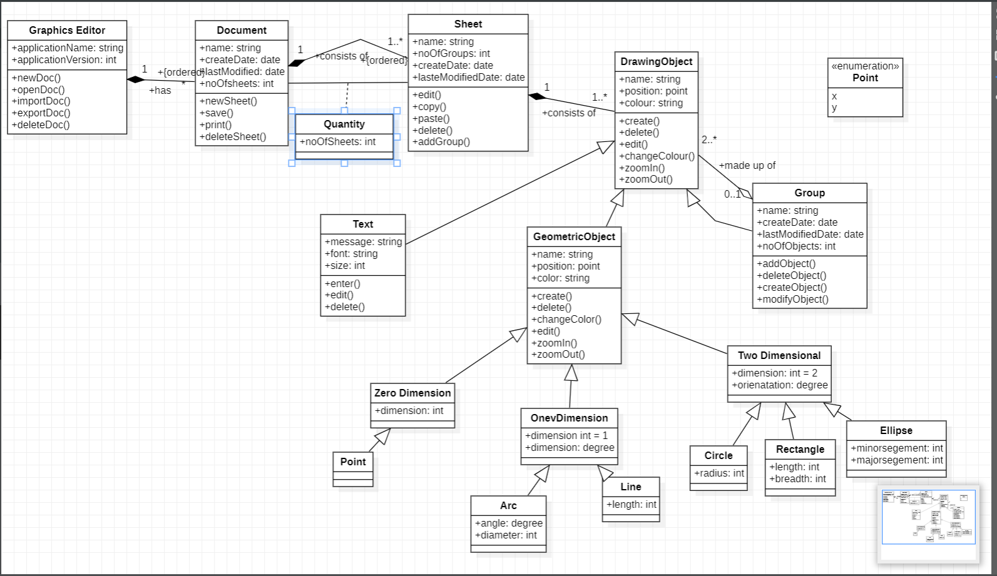

ADVANCED STATE DIAGRAM

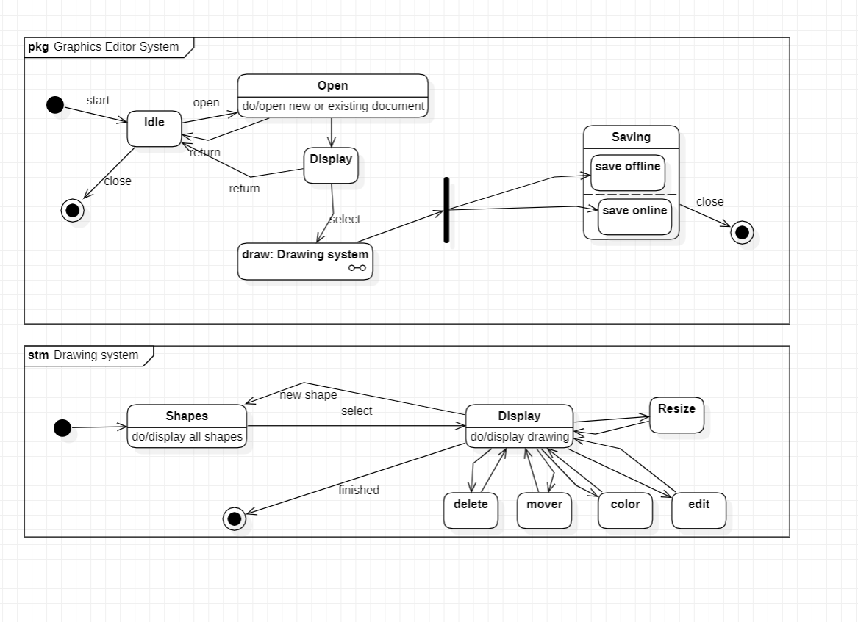

ADVANCED USE CASE DIAGRAM

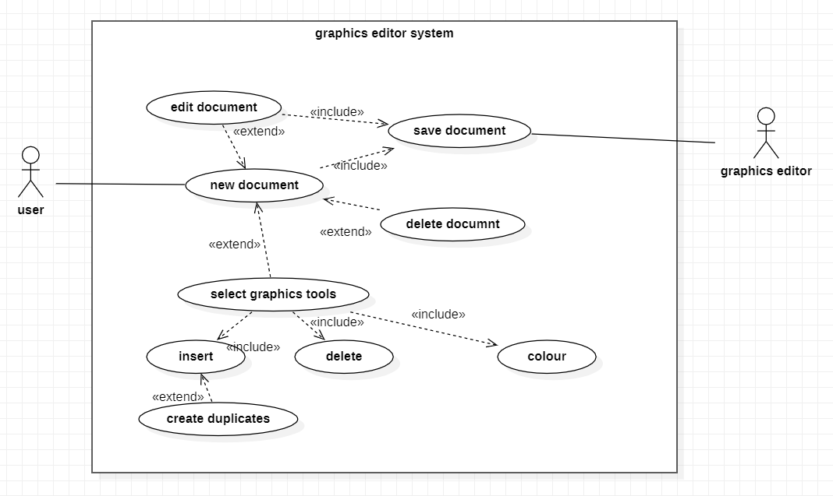

ADVANCED ACTIVITY DIAGRAM

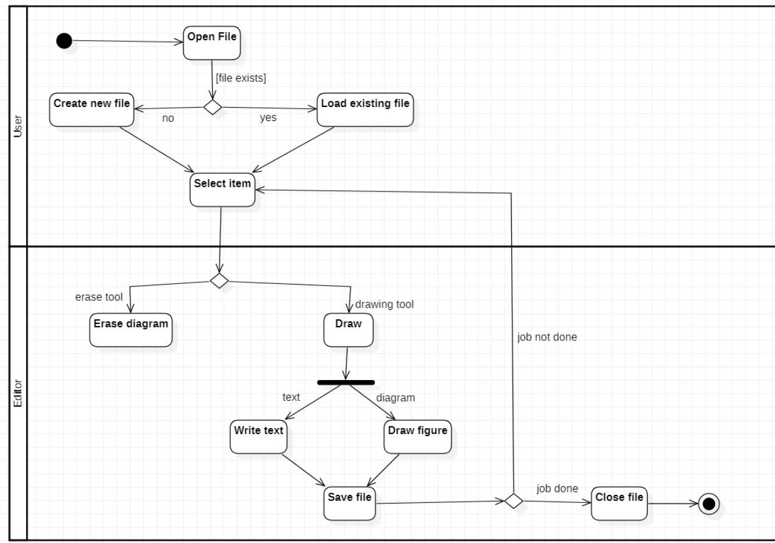

ADVANCED SEQUENCE DIAGRAM

